Quaid-e-Awam University of Engineering Science & Technology Nawabshah
Software Engineering Department, Subject: Data Science Practical

 |  | 

DEPARTMENT OF SOFTWARE ENGINEERING
Quaid-e-Awam University of Engineering, Science & Technology Nawabshah

PRACTICAL WORKBOOK

for the subject

Data Science

NAME:
ROLL:



DEPARTMENT OF SOFTWARE ENGINEERING
Quaid-e-Awam University of Engineering, Science & Technology Nawabshah

Practical Work
Course: |  |  | Data Science | Course Code: |  |  |  |  | SW402
Teacher Name: |  |  | Mr. Zohaib Ahmed | Department: |  |  |  |  | Software Engineering
Semester, Year: |  |  | 1st Semester, 4th Year | Batch: |  |  |  |  | 20SW
Class Learning Outcomes (CLOs)
SN | Description |  |  |  | PLO | Level |  | Assessment (50)
 |  |  |  |  |  |  |  | Assignment (10) | Objective (20) | Viva (20)
1 | Practice Apply data science techniques to analyze datasets using various libraries and tools |  |  |  | 5 | P3 |  | 20 | 10 | 20
Practical Objectives
 |  |  |  |  |  |  | Associated CLO |  | Hours | Date
1 |  | To work with NumPy arrays |  |  |  |  | 1 |  | 3
2 |  | To work with Pandas data frames |  |  |  |  | 1 |  | 3
3 |  | To work with Matplotlib |  |  |  |  | 1 |  | 3
4 |  | To work with frequency distributions to analyze the distribution of values |  |  |  |  | 1 |  | 3
5 |  | To work with calculating averages (mean, median, mode) |  |  |  |  | 1 |  | 3
6 |  | To work with measuring variability (range, variance, standard deviation) |  |  |  |  | 1 |  | 3
7 |  | To work with normal distribution curves |  |  |  |  | 1 |  | 3
8 |  | To work with correlation analysis and scatter plots |  |  |  |  | 1 |  | 3
9 |  | To work with calculating correlation coefficients (Pearson, Spearman) |  |  |  |  | 1 |  | 3
10 |  | To work with linear regression analysis |  |  |  |  | 1 |  | 3
11 |  | To work with hypothesis testing techniques |  |  |  |  | 1 |  | 3
12 |  | To work with dimensionality reduction techniques (e.g., PCA, t-SNE) |  |  |  |  | 1 |  | 3
13 |  | To work with time series analysis techniques |  |  |  |  | 1 |  | 3
14 |  | To work with deep learning frameworks (e.g., TensorFlow, Keras) |  |  |  |  | 1 |  | 3
15 |  | Case study /Open-ended lab |  |  |  |  | 1 |  | 3

Name & Signature of Teacher: ______________________________ Date: _________________

Practical 01
Objective:
To work with NumPy arrays for efficient numerical computation and data manipulation in Python.


Overview of NumPy and its features:
NumPy, short for Numerical Python, is a powerful Python library primarily used for numerical computing. It provides support for multidimensional arrays and matrices, along with an extensive collection of mathematical functions to operate on these arrays efficiently. Some key features of
NumPy include:
- Multidimensional arrays: NumPy provides a data structure called ndarray, which represents arrays of arbitrary dimensions. These arrays can be one-dimensional, two-dimensional, or even higher-dimensional.
- Mathematical functions: NumPy offers a wide range of mathematical functions for performing array operations, including basic arithmetic operations, trigonometric functions, exponential and logarithmic functions, statistical functions, etc.
- Broadcasting: NumPy implements broadcasting rules that allow for operations between arrays of different shapes, making it easier to perform element-wise operations without explicitly reshaping arrays.
- Vectorized operations: NumPy supports vectorized operations, which enable efficient computation by applying operations element-wise on arrays, avoiding the need for explicit loops.
- Integration with other libraries: NumPy integrates seamlessly with other Python libraries used in scientific computing and data analysis, such as SciPy, pandas, Matplotlib, scikit-learn, etc.
Installing NumPy using pip or conda:
NumPy can be easily installed using either pip or conda, Python's package managers.
Using pip: pip install numpy
Using conda: conda install numpy
If you're using Anaconda as your Python distribution, conda is the preferred package manager for installing NumPy and other scientific computing libraries. However, if you're using the standard Python distribution, pip can be used to install NumPy and its dependencies.
Once installed, NumPy can be imported into your Python scripts or interactive sessions using:

Creating NumPy Arrays:
Creating NumPy arrays involves initializing arrays with desired data. This can be done in various ways such as converting Python lists or tuples into arrays, using built-in functions, or reading data from files.
import numpy as np
# Creating NumPy arrays from Python lists
my_list = [1, 2, 3, 4, 5]
my_array = np.array(my_list)
print("Array created from list:", my_array)
# Generating arrays using built-in functions
zeros_array = np.zeros((2, 3))
print("Zeros array:", zeros_array)
ones_array = np.ones((3, 2))
print("Ones array:", ones_array)
range_array = np.arange(0, 10, 2)
print("Range array:", range_array)
Array Operations:
Array operations involve performing various mathematical operations on arrays, including addition, subtraction, multiplication, division, etc. These operations can be performed element-wise or using NumPy's broadcasting capabilities.

import numpy as np

# Creating NumPy arrays
a = np.array([1, 2, 3])
b = np.array([4, 5, 6])
# Basic arithmetic operations with arrays
sum_array = a + b
diff_array = a - b
product_array = a * b
quotient_array = a / b
print("Sum array:", sum_array)
print("Difference array:", diff_array)
print("Product array:", product_array)
print("Quotient array:", quotient_array)
Indexing and Slicing:
Indexing and slicing allow accessing specific elements or subarrays within a NumPy array. This provides flexibility in extracting data for further analysis or manipulation.
import numpy as np
# Creating a NumPy array
arr = np.array([1, 2, 3, 4, 5])
# Indexing and slicing
print("Element at index 2:", arr[2])
print("Slicing from index 1 to 3:", arr[1:4])

Array Manipulation:
Array manipulation involves changing the shape, size, or content of arrays. This includes operations like concatenating arrays, splitting arrays, stacking arrays, etc.
import numpy as np

# Creating NumPy arrays
arr1 = np.array([[1, 2], [3, 4]])
arr2 = np.array([[5, 6], [7, 8]])

# Concatenating arrays
concatenated_array = np.concatenate((arr1, arr2), axis=0)
print("Concatenated array:")
print(concatenated_array)

# Stacking arrays vertically
stacked_array = np.vstack((arr1, arr2))
print("Vertically stacked array:")
print(stacked_array)

Aggregation and Statistical Operations:
Aggregation and statistical operations involve computing summary statistics such as mean, median, sum, standard deviation, etc., for arrays.
import numpy as np
# Creating a NumPy array
arr = np.array([[1, 2, 3], [4, 5, 6]])
# Computing basic statistical measures
print("Mean:", np.mean(arr))
print("Median:", np.median(arr))
print("Sum:", np.sum(arr))

Broadcasting and Vectorization:
Broadcasting and vectorization are NumPy concepts that enable efficient element-wise operations on arrays with different shapes or sizes without the need for explicit looping.
import numpy as np

# Creating NumPy arrays
a = np.array([[1, 2, 3], [4, 5, 6]])
b = np.array([10, 20, 30])

# Broadcasting
result = a + b
print("Result of broadcasting:")
print(result)
These examples illustrate the definitions of each term along with practical examples to demonstrate their usage in NumPy arrays.

Outcome:
This lab introduces students to NumPy arrays, a fundamental tool for efficient numerical computation and data manipulation in Python. They learn to create arrays from Python lists, use built-in functions for array generation, and manipulate arrays through indexing, slicing, and aggregation operations. Students also explore broadcasting and vectorization concepts, enabling them to perform element-wise operations on arrays efficiently. By the end of the lab, students gain practical experience in utilizing NumPy arrays for various scientific computing and data analysis tasks.

Task 1: Create and Manipulate NumPy Arrays
- Create a NumPy array arr1 containing integers from 1 to 10 using the numpy.arange() function.
- Reshape arr1 into a 2x5 array and assign it to a new variable arr2.
- Create another NumPy array arr3 containing all zeros of shape (3, 4) using the numpy.zeros() function.
- Concatenate arr2 and arr3 along the rows and print the resulting array.
- Compute the mean and median of the concatenated array along the columns.
Task 2: Broadcasting and Statistical Operations
- Create a NumPy array x of shape (3, 3) containing values 1, 2, and 3 along the rows using the numpy.ones() function.
- Create another NumPy array y of shape (3, 1) containing values 4, 5, and 6 using the numpy.arange() function.
- Add y to x using broadcasting and print the result.
- Compute the sum of elements in the resulting array.
- Compute the standard deviation of elements in the resulting array.
Task 3: Indexing, Slicing, and Aggregation
- Create a NumPy array data containing numbers from 0 to 19.
- Print the element at index 5 of data.
- Slice data to extract elements from index 10 to the end and assign it to a new variable subset.
- Compute the sum and mean of elements in subset.
- Create a 3x3 NumPy array matrix containing numbers from 1 to 9.
- Print the second row and third column of matrix.

Lab Rubrics

Course: | Data Science | Course Code:
Student Name: |  | Student Roll No.:
Semester, Year: | 1nd Semester, 4rd Year | Date:

SN | Components | Level of Achievement |  |  | Marks Achieved
 |  | Proficient  0.25 | Acceptable  0.15 | Unacceptable  0
1 | Problem Understanding and Analysis | Students have carefully read and understood the problem. Students gives the idea to solve problem | Student understands problems and analysis in an acceptable way | Student don’t understand problem.
2 | Ability to use software/hardware | Student was familiar with the software/hardware and required minimal help from the instructor to perform the experiment | Student demonstrated an ability to use the software/hardware but required assistance from the instructor | Student demonstrated little or no ability to perform experiment and required unreasonable amount of assistance from instructor
3 | Completeness and accuracy | The lab /tasks are complete and accurate in the context of implementation | The lab completion is just acceptable | The lab in its current state is not implementable
4 | Q &A | Able to explain design/program/simulation/fundamental concepts correctly | Able to explain some design/program/simulation/fundamental concepts | Unable to explain design/program/simulation/fundamental Concepts
Total (1)

Name & Signature of Teacher: _____________________ Date: _________________

Practical 02
Objective: To work with Pandas data frames for handling structured data and performing data manipulation tasks in Python.
Introduction to Pandas:
Pandas is an open-source Python library used for data manipulation and analysis. It provides powerful data structures and functions to work with structured data efficiently. Pandas is widely used in data science, machine learning, and data analysis due to its flexibility and ease of use.
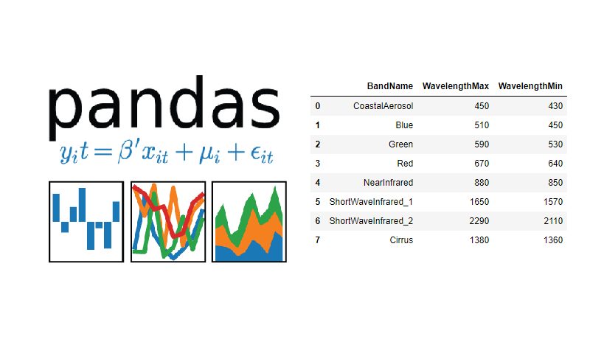
Features and Role in Data Science:
DataFrame: Pandas introduces the DataFrame data structure, which is a two-dimensional labeled data structure with columns of potentially different types. It is similar to a spreadsheet or SQL table, making it suitable for data manipulation and analysis tasks.
Series: Pandas also provides the Series data structure, which is a one-dimensional labeled array capable of holding data of any type.
Data Manipulation: Pandas offers a wide range of functions for data manipulation tasks such as merging, reshaping, slicing, filtering, and aggregating data.
Data Cleaning: Pandas facilitates data cleaning tasks by providing functions to handle missing data, duplicate values, and outliers.
Data Analysis: Pandas enables data analysis by offering functions for computing summary statistics, performing group-by operations, and visualizing data.
Integration: Pandas seamlessly integrates with other Python libraries such as NumPy, Matplotlib, and Scikit-learn, making it a valuable tool in the data science ecosystem.

Advantages of Pandas:
Ease of Use: Pandas provides a user-friendly and intuitive interface for data manipulation and analysis tasks, making it accessible to users with varying levels of programming experience.
Flexibility: Pandas offers flexibility in handling various types of data, including structured and semi-structured data, making it suitable for a wide range of applications.
Performance: Pandas is optimized for performance, allowing for efficient processing of large datasets and complex data manipulation operations.
Rich Functionality: Pandas provides a rich set of functions and methods for data manipulation, analysis, and visualization, reducing the need for writing custom code for common data tasks.
Installation:
Pandas can be installed using pip, the Python package installer. Open a terminal or command prompt and run the following command:
pip install pandas
DataFrame:
A DataFrame is a two-dimensional labeled data structure with columns of potentially different types. It is similar to a spreadsheet or SQL table, where data is organized into rows and columns. Each column in a DataFrame represents a different variable, while each row represents a different observation or sample.
Series:
A Series is a one-dimensional labeled array capable of holding data of any type. It is similar to a one-dimensional array or list in Python but includes additional features such as labeled indexing. Each element in a Series has a corresponding label, which can be used to access the data.
Here is an example code demonstrating basic operations with Pandas DataFrames:
import pandas as pd
# Creating a DataFrame from a dictionary
data = {'Name': ['Alice', 'Bob', 'Charlie', 'David'],
'Age': [25, 30, 35, 40],
'City': ['New York', 'Los Angeles', 'Chicago', 'Houston']}
df = pd.DataFrame(data)
print("DataFrame created from dictionary:")
print(df)
print()

# Accessing specific columns
print("Accessing specific columns:")
print(df['Name'])
print(df[['Name', 'Age']])
print()

# Accessing specific rows
print("Accessing specific rows using iloc:")
print(df.iloc[0]) # First row
print(df.iloc[1:3]) # Second and third rows
print()

# Adding a new column
df['Gender'] = ['Female', 'Male', 'Male', 'Female']
print("DataFrame after adding a new column:")
print(df)
print()

# Filtering rows based on a condition
print("Filtering rows based on a condition:")
print(df[df['Age'] > 30])
print()

# Summary statistics
print("Summary statistics:")
print(df.describe())

Output:
DataFrame created from dictionary:
Name Age City
0 Alice 25 New York
1 Bob 30 Los Angeles
2 Charlie 35 Chicago
3 David 40 Houston

Accessing specific columns:
0 Alice
1 Bob
2 Charlie
3 David
Name: Name, dtype: object
Name Age
0 Alice 25
1 Bob 30
2 Charlie 35
3 David 40

Accessing specific rows using iloc:
Name Alice
Age 25
City New York
Name: 0, dtype: object
Name Age City
1 Bob 30 Los Angeles
2 Charlie 35 Chicago

DataFrame after adding a new column:
Name Age City Gender
0 Alice 25 New York Female
1 Bob 30 Los Angeles Male
2 Charlie 35 Chicago Male
3 David 40 Houston Female

Filtering rows based on a condition:
Name Age City Gender
2 Charlie 35 Chicago Male
3 David 40 Houston Female

Summary statistics:
Age
count 4.000000
mean 32.500000
std 6.454972
min 25.000000
25% 28.750000
50% 32.500000
75% 36.250000
max 40.000000

Lab Task:
Dataset Sample:
Consider the following sample dataset containing information about students' grades in different subjects:
Student ID | Math | Science | English
1 | 85 | 78 | 92
2 | 72 | 88 | 65
3 | 90 | 82 | 75
4 | 78 | 75 | 80
5 | 68 | 90 | 70
Questions for DataFrame Task:
Data Loading:
- Load the sample dataset into a Pandas DataFrame.
Exploratory Analysis:
- Display the first 5 rows of the DataFrame to understand its structure.
- Calculate and display the average grade for each subject (Math, Science, English).
Data Manipulation:
- Add a new column named "Pass/Fail Math" indicating whether each student passed or failed in Math (passing grade >= 60).
- Add a new column named "Total Grade" containing the total grade obtained by each student (sum of Math, Science, English).
Data Saving:
- Save the modified DataFrame to a new CSV file named "student_grades_modified.csv".
Expected Output:
- Data Loading:
Load the sample dataset into a Pandas DataFrame named student_grades.
- Exploratory Analysis:
Display the first 5 rows of the DataFrame student_grades.
Average grade for each subject: Math - 78.6, Science - 82.6, English - 76.4.
- Data Manipulation:
Modify the DataFrame student_grades by adding the columns "Pass/Fail Math" and "Total Grade".
Display the modified DataFrame.
- Data Saving:
Save the modified DataFrame student_grades to a new CSV file named "student_grades_modified.csv".

Instructions for Students:
Load the provided sample dataset into a Pandas DataFrame named student_grades.
Perform the required exploratory analysis tasks to understand the structure of the dataset and calculate average grades for each subject.
Manipulate the DataFrame to add new columns as specified in the questions and display the modified DataFrame.
Save the modified DataFrame to a new CSV file named "student_grades_modified.csv".
By completing these tasks, students will gain practical experience in working with Pandas DataFrames for data manipulation and analysis, reinforcing the concepts learned during the lab session.

Outcome
By completing this lab, students will gain proficiency in working with Pandas DataFrames for efficient handling of structured data and performing various data manipulation tasks in Python.

Lab Rubrics

Course: | Data Science | Course Code:
Student Name: |  | Student Roll No.:
Semester, Year: | 1nd Semester, 4rd Year | Date:

SN | Components | Level of Achievement |  |  | Marks Achieved
 |  | Proficient  0.25 | Acceptable  0.15 | Unacceptable  0
1 | Problem Understanding and Analysis | Students have carefully read and understood the problem. Students gives the idea to solve problem | Student understands problems and analysis in an acceptable way | Student don’t understand problem.
2 | Ability to use software/hardware | Student was familiar with the software/hardware and required minimal help from the instructor to perform the experiment | Student demonstrated an ability to use the software/hardware but required assistance from the instructor | Student demonstrated little or no ability to perform experiment and required unreasonable amount of assistance from instructor
3 | Completeness and accuracy | The lab /tasks are complete and accurate in the context of implementation | The lab completion is just acceptable | The lab in its current state is not implementable
4 | Q &A | Able to explain design/program/simulation/fundamental concepts correctly | Able to explain some design/program/simulation/fundamental concepts | Unable to explain design/program/simulation/fundamental Concepts
Total (1)

Name & Signature of Teacher: _____________________ Date: _________________

Practical 03
Objective: To work with Matplotlib for creating basic plots such as line plots, scatter plots, and histograms to visualize data distributions.
Introduction
Matplotlib is a comprehensive library for creating static, animated, and interactive visualizations in Python. It is widely used for data visualization in various fields such as data science, machine learning, statistics, finance, and more. Matplotlib provides a wide variety of plotting functions and customization options to create high-quality plots for exploratory data analysis, presentation, and publication.
Here are some key points about Matplotlib:
Purpose: Matplotlib is used to create visualizations such as line plots, scatter plots, bar plots, histograms, pie charts, 3D plots, and more. It helps in understanding patterns, trends, and relationships within data.
Usage: Matplotlib is extensively used in data science projects for data visualization tasks such as data exploration, model evaluation, and result presentation. It is also used in scientific computing for plotting mathematical functions, experimental data, and simulation results.
Installation: Matplotlib can be installed using the Python package manager pip. You can install it by running the following command in your terminal or command prompt:
pip install matplotlib
Usage in Data Science Projects: In data science projects, Matplotlib is typically used along with other libraries such as NumPy, pandas, and scikit-learn. It helps in visualizing data distributions, relationships between variables, model performance, and more. Matplotlib plots can be embedded in Jupyter notebooks, web applications, and desktop GUIs.
Integration with Pandas: Matplotlib can be integrated seamlessly with the pandas library, which is widely used for data manipulation and analysis in Python. Pandas DataFrame objects have built-in methods for creating plots using Matplotlib.
Customization: Matplotlib offers extensive customization options to control every aspect of the plot, including axes, labels, titles, colors, styles, fonts, and more. It allows users to create highly customizable plots tailored to their specific requirements.
Matplotlib and Seaborn: Seaborn is a statistical data visualization library built on top of Matplotlib. It provides a higher-level interface for creating attractive and informative statistical graphics. Seaborn simplifies the process of creating complex plots such as violin plots, box plots, pair plots, and heatmaps by abstracting away some of the low-level details. While Matplotlib is more versatile and customizable, Seaborn is more focused on statistical visualization and aesthetics.
In summary, Matplotlib is a powerful library for creating a wide range of plots and visualizations in Python. It is widely used in data science projects for exploring and presenting data in a clear and insightful manner. With its extensive customization options and integration with other libraries, Matplotlib provides a flexible and versatile tool for data visualization tasks.
ALGORITHM
Step1: Start
Step2: import Matplotlib module
Step3: Create a Basic plots using Matplotlib
Step4: Print the output
Step5: Stop

- Start: This step signifies the beginning of the algorithm or program.
- Import Matplotlib Module: In this step, the program imports the Matplotlib library's pyplot module using the alias plt. This module provides a MATLAB-like interface for creating plots.
- Create a Basic Plot using Matplotlib: The program defines two lists, x and y, which represent the x-axis and y-axis values respectively. These lists contain the coordinates of points to be plotted. Then, it uses the plot() function from Matplotlib to create a line plot with the points defined by x and y.
- Print the Output: Although not explicitly mentioned in the program, after executing the plotting commands, the output of the plot will be displayed. In Jupyter notebooks or interactive environments, the plot will be automatically displayed. In non-interactive environments, like scripts or non-interactive terminals, the plot can be displayed using plt.show().
- Stop: This step signifies the end of the algorithm or program.
Program: 01
# importing the required module import matplotlib.pyplot as plt

# x axis values x = [1,2,3]
# corresponding y axis values y = [2,4,1]

# plotting the points plt.plot(x, y)

# naming the x axis plt.xlabel('x - axis') # naming the y axis plt.ylabel('y - axis')

# giving a title to my graph plt.title('My first graph!')

# function to show the plot plt.show()

Output:
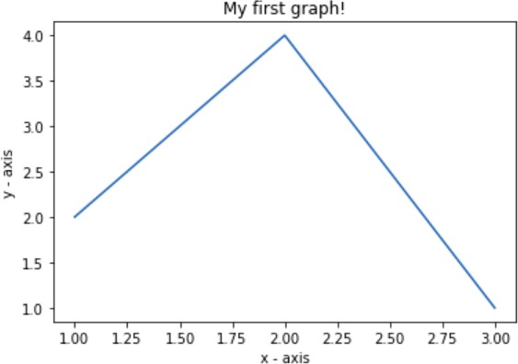

Program: 02
import matplotlib.pyplot as plt a = [1, 2, 3, 4, 5]
b = [0, 0.6, 0.2, 15, 10, 8, 16, 21]
plt.plot(a)

# o is for circles and r is # for red
plt.plot(b, "or") plt.plot(list(range(0, 22, 3)))
# naming the x-axis plt.xlabel('Day ->')

# naming the y-axis plt.ylabel('Temp ->')

c = [4, 2, 6, 8, 3, 20, 13, 15]
plt.plot(c, label = '4th Rep')

# get current axes command ax = plt.gca()

# get command over the individual # boundary line of the graph body ax.spines['right'].set_visible(False) ax.spines['top'].set_visible(False)

# set the range or the bounds of
# the left boundary line to fixed range ax.spines['left'].set_bounds(-3, 40)

# set the interval by which # the x-axis set the marks
plt.xticks(list(range(-3, 10)))

# set the intervals by which y-axis # set the marks plt.yticks(list(range(-3, 20, 3)))

# legend denotes that what color # signifies what
ax.legend(['1st Rep', '2nd Rep', '3rd Rep', '4th Rep'])

# annotate command helps to write
# ON THE GRAPH any text xy denotes # the position on the graph
plt.annotate('Temperature V / s Days', xy = (1.01, -2.15))

# gives a title to the Graph plt.title('All Features Discussed') plt.show()

Output:

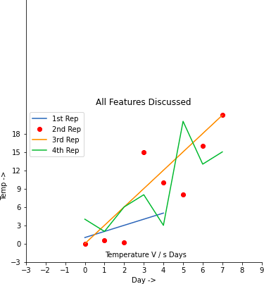

Program: 03
import matplotlib.pyplot as plt

a = [1, 2, 3, 4, 5]
b = [0, 0.6, 0.2, 15, 10, 8, 16, 21]
c = [4, 2, 6, 8, 3, 20, 13, 15]

# use fig whenever u want the # output in a new window also # specify the window size you # want ans to be displayed
fig = plt.figure(figsize =(10, 10))

# creating multiple plots in a # single plot
sub1 = plt.subplot(2, 2, 1)
sub2 = plt.subplot(2, 2, 2)
sub3 = plt.subplot(2, 2, 3)
sub4 = plt.subplot(2, 2, 4) sub1.plot(a, 'sb')
# sets how the display subplot # x axis values advances by 1 # within the specified range
sub1.set_xticks(list(range(0, 10, 1))) sub1.set_title('1st Rep')

sub2.plot(b, 'or')

# sets how the display subplot x axis # values advances by 2 within the
# specified range sub2.set_xticks(list(range(0, 10, 2))) sub2.set_title('2nd Rep')

# can directly pass a list in the plot
# function instead adding the reference sub3.plot(list(range(0, 22, 3)), 'vg')
sub3.set_xticks(list(range(0, 10, 1))) sub3.set_title('3rd Rep')

sub4.plot(c, 'Dm')

# similarly we can set the ticks for # the y-axis range(start(inclusive), # end(exclusive), step)
sub4.set_yticks(list(range(0, 24, 2))) sub4.set_title('4th Rep')

# without writing plt.show() no plot # will be visible
plt.show()
Output:
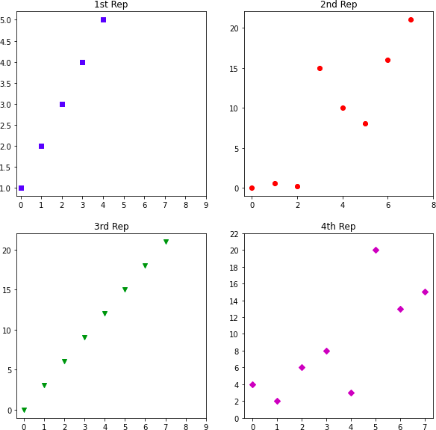

Lab Task
Task 1: Scatter Plot Analysis
Objective: The objective of this task is to introduce students to scatter plots and basic data analysis using Matplotlib. Students will create a scatter plot from a sample dataset and perform simple analysis to understand the relationship between two variables.
Sample Dataset:
# Sample dataset: Student scores (Math vs. Science)
student_names = ['Alice', 'Bob', 'Charlie', 'David', 'Emma']
math_scores = [85, 70, 90, 65, 95]
science_scores = [75, 80, 85, 60, 90]
Task Description:
Create a Scatter Plot:
Plot math_scores on the x-axis and science_scores on the y-axis to create a scatter plot.
Label the x-axis as "Math Scores" and the y-axis as "Science Scores".
Analysis:
Analyze the scatter plot to identify any patterns or trends between math and science scores.
Discuss with your peers the relationship between the two variables based on the plotted data.
Conclusion:
Write a brief conclusion summarizing your observations from the scatter plot analysis. Discuss any insights gained from the plotted data.
Task 2: Histogram Visualization
Objective: The objective of this task is to introduce students to histograms and data distribution visualization using Matplotlib. Students will create a histogram from a sample dataset and analyze the distribution of values.
Sample Dataset:
# Sample dataset: Exam scores
exam_scores = [75, 80, 85, 90, 85, 92, 88, 78, 80, 82, 95, 88, 90, 92, 85]
Task Description:
Create a Histogram:
Plot the exam_scores dataset as a histogram.
Choose an appropriate number of bins to represent the distribution of scores.
Analysis:
Analyze the histogram to understand the distribution of exam scores.
Identify any trends or patterns in the distribution of scores, such as central tendency and variability.
Conclusion:
Write a brief conclusion summarizing your observations from the histogram analysis. Discuss the distribution characteristics of the exam scores based on the plotted histogram.

Outcome:
In Practical 03, students will utilize Matplotlib to create basic plots including line plots, scatter plots, and histograms, enabling visualization of data distributions.

Lab Rubrics

Course: | Data Science | Course Code:
Student Name: |  | Student Roll No.:
Semester, Year: | 1nd Semester, 4rd Year | Date:

SN | Components | Level of Achievement |  |  | Marks Achieved
 |  | Proficient  0.25 | Acceptable  0.15 | Unacceptable  0
1 | Problem Understanding and Analysis | Students have carefully read and understood the problem. Students gives the idea to solve problem | Student understands problems and analysis in an acceptable way | Student don’t understand problem.
2 | Ability to use software/hardware | Student was familiar with the software/hardware and required minimal help from the instructor to perform the experiment | Student demonstrated an ability to use the software/hardware but required assistance from the instructor | Student demonstrated little or no ability to perform experiment and required unreasonable amount of assistance from instructor
3 | Completeness and accuracy | The lab /tasks are complete and accurate in the context of implementation | The lab completion is just acceptable | The lab in its current state is not implementable
4 | Q &A | Able to explain design/program/simulation/fundamental concepts correctly | Able to explain some design/program/simulation/fundamental concepts | Unable to explain design/program/simulation/fundamental Concepts
Total (1)

Name & Signature of Teacher: _____________________ Date: _________________

Practical 04
Objective: To work with frequency distributions to analyze the distribution of values in datasets and understand data spread.
Introduction
A frequency distribution is a summary of data that shows the frequency or count of each value in a dataset. It organizes data into categories and displays the number of occurrences of each category. Frequency distributions are commonly used in statistical analysis to understand the distribution and pattern of data.
Steps to Construct a Frequency Distribution:
- Identify the Data Set: Determine the dataset for which you want to create a frequency distribution.
- Determine the Range: Calculate the range of the data, which is the difference between the maximum and minimum values.
- Determine the Number of Intervals (Classes): Decide on the number of intervals (or classes) to divide the data. This can be determined using mathematical formulas like Sturges' rule or by considering the nature of the data and the desired level of detail.
- Calculate the Width of Intervals: Divide the range of the data by the number of intervals to determine the width of each interval.
- Create Intervals: Divide the range of the data into intervals of equal width.
- Tally the Frequencies: Count the number of data points that fall into each interval. This gives the frequency of each interval.
- Construct the Frequency Distribution Table: Create a table that lists the intervals (or classes) along with their corresponding frequencies.
- Optional: Create Histogram or Frequency Polygon: Visualize the frequency distribution using a histogram (for continuous data) or a frequency polygon (for discrete data).
Analysis of Frequency Distribution:
Once the frequency distribution is constructed, it can be analyzed to gain insights into the distribution of values within the dataset:
Central Tendency: Determine the central tendency of the data using measures like the mean, median, or mode.
Dispersion: Assess the spread or dispersion of the data using measures like range, variance, or standard deviation.
Shape: Examine the shape of the distribution (e.g., symmetrical, skewed, uniform) by visually inspecting the histogram or frequency polygon.
Outliers: Identify any outliers or unusual data points that fall outside the typical range of values.
Patterns: Look for any patterns or trends in the distribution that may reveal underlying characteristics of the data.
Frequency distributions provide a structured way to organize and analyze data, allowing researchers to understand the distribution and patterns within a dataset. By examining the frequency distribution, researchers can draw conclusions about the central tendency, dispersion, shape, outliers, and patterns present in the data. This information is valuable for making informed decisions and drawing meaningful insights from the data.
ALGORITHM
Let's implement a practical example in Python to work with frequency distributions using a sample dataset. We'll use the numpy and matplotlib libraries for this purpose. If you don't have them installed, you can install them using pip install numpy matplotlib.
import numpy as np
import matplotlib.pyplot as plt

# Sample data (let's assume these are exam scores)
data = np.array([65, 70, 82, 78, 92, 75, 88, 95, 78, 82, 85, 90, 88, 78, 85, 92, 90, 75, 82, 85])

# Determine the range of the data
data_range = np.ptp(data)

# Determine the number of intervals (classes) using Sturges' rule
num_intervals = int(np.ceil(1 + np.log2(len(data))))

# Calculate the width of intervals
interval_width = data_range / num_intervals

# Create intervals
intervals = [round(data.min() + i * interval_width, 2) for i in range(num_intervals + 1)]

# Tally the frequencies
frequencies, _ = np.histogram(data, bins=intervals)

# Construct the frequency distribution table
frequency_table = {f'{intervals[i]} - {intervals[i+1]}': frequencies[i] for i in range(len(frequencies))}

# Print frequency distribution table
print("Frequency Distribution Table:")
print("Interval\tFrequency")
for interval, frequency in frequency_table.items():
print(f"{interval}\t{frequency}")

# Create a histogram to visualize the frequency distribution
plt.hist(data, bins=intervals, edgecolor='black')
plt.xlabel('Score Intervals')
plt.ylabel('Frequency')
plt.title('Frequency Distribution of Exam Scores')
plt.xticks(intervals)
plt.grid(True)
plt.show()
Output:
Frequency Distribution Table:
Interval Frequency
65.0 - 70.0 1
70.0 - 75.0 1
75.0 - 80.0 5
80.0 - 85.0 3
85.0 - 90.0 5
90.0 - 95.0 5
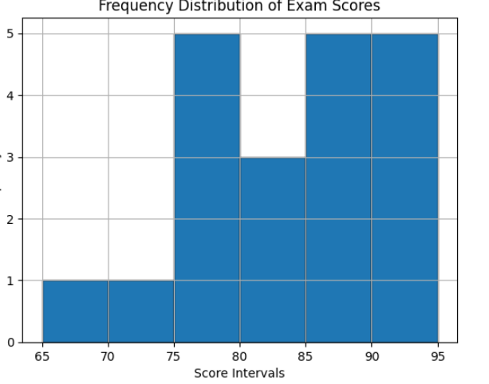

Lab Task:
Analyzing Student Grades
Objective: To create a frequency distribution of student grades and visualize it using a histogram.
Instructions:
- Generate a sample dataset representing student grades in a class. You can use numpy.random.randint to generate random grades.
- Determine the range of the grades.
- Use Sturges' rule to determine the number of intervals (classes).
- Calculate the width of each interval.
- Create intervals based on the calculated width.
- Count the frequencies of grades falling into each interval using numpy.histogram.
- Visualize the frequency distribution using a histogram.

Outcome:
The outcome of this practical is a visual representation of the frequency distribution of student grades using a histogram.

Lab Rubrics

Course: | Data Science | Course Code:
Student Name: |  | Student Roll No.:
Semester, Year: | 1nd Semester, 4rd Year | Date:

SN | Components | Level of Achievement |  |  | Marks Achieved
 |  | Proficient  0.25 | Acceptable  0.15 | Unacceptable  0
1 | Problem Understanding and Analysis | Students have carefully read and understood the problem. Students gives the idea to solve problem | Student understands problems and analysis in an acceptable way | Student don’t understand problem.
2 | Ability to use software/hardware | Student was familiar with the software/hardware and required minimal help from the instructor to perform the experiment | Student demonstrated an ability to use the software/hardware but required assistance from the instructor | Student demonstrated little or no ability to perform experiment and required unreasonable amount of assistance from instructor
3 | Completeness and accuracy | The lab /tasks are complete and accurate in the context of implementation | The lab completion is just acceptable | The lab in its current state is not implementable
4 | Q &A | Able to explain design/program/simulation/fundamental concepts correctly | Able to explain some design/program/simulation/fundamental concepts | Unable to explain design/program/simulation/fundamental Concepts
Total (1)

Name & Signature of Teacher: _____________________ Date: _________________

Practical 05
Objective: To work with calculating averages (mean, median, mode) to summarize central tendencies in datasets.
Introduction:
In statistics, measures of central tendency are used to summarize a dataset by providing a single representative value that describes the center or typical value of the data. These measures include the mean, median, and mode, each of which offers insights into different aspects of the data distribution.
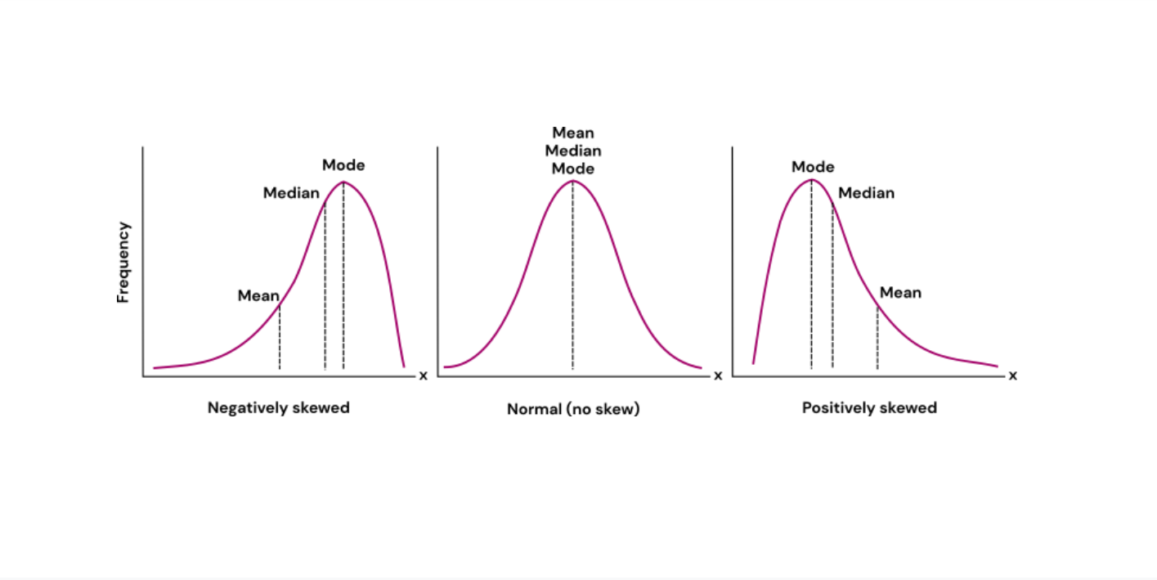
Why We Use It:
Measures of central tendency are essential tools in statistical analysis for several reasons:
- Summary Statistics: They provide a concise summary of the dataset, allowing researchers and analysts to understand the central or typical value around which the data cluster.
- Comparative Analysis: Central tendency measures enable comparisons between different datasets or subsets of data. For example, comparing the average income of two populations or the median age of different groups.
- Predictive Modeling: In predictive modeling and machine learning, measures of central tendency are often used as features to train models and make predictions.
- Decision Making: Central tendency measures inform decision-making processes in various fields, including business, finance, healthcare, and social sciences.
Terms:
- Mean: The mean, also known as the arithmetic average, is calculated by summing up all values in the dataset and dividing the sum by the total number of values. It is sensitive to extreme values, making it useful for symmetrically distributed data.
- Median: The median is the middle value in a sorted dataset. If the dataset has an odd number of values, the median is the middle value. If the dataset has an even number of values, the median is the average of the two middle values. It is less affected by outliers compared to the mean and is useful for skewed distributions.
- Mode: The mode is the value that appears most frequently in the dataset. A dataset may have one mode (unimodal), two modes (bimodal), or more modes (multimodal). It is useful for identifying the most common value or category in categorical data.
How Python Helps Us:
Python offers a variety of libraries and functions that facilitate the calculation of central tendency measures:
- NumPy: NumPy is a fundamental library for numerical computing in Python. It provides efficient functions for array manipulation and mathematical operations, including calculating the mean and median.
- SciPy: SciPy is a scientific computing library that builds on NumPy and provides additional functionality for scientific and technical computing tasks, including statistical functions such as mode calculation.
- pandas: pandas is a powerful library for data manipulation and analysis in Python. It provides data structures like DataFrame and Series, which are equipped with methods for calculating descriptive statistics, including mean, median, and mode.
- Statistics Module: Python's built-in statistics module offers functions for calculating basic statistical measures, including mean, median, and mode, directly from lists or iterables.
In summary, calculating averages (mean, median, mode) is a fundamental aspect of statistical analysis used to summarize central tendencies in datasets. These measures provide valuable insights into the distribution and characteristics of data, aiding decision-making processes, comparative analysis, and predictive modeling. Python offers a variety of libraries and functions that make it convenient to calculate these measures and analyze data efficiently. By understanding and applying measures of central tendency, analysts and researchers can gain valuable insights from data and make informed decisions in various fields.

ALGORITHM

Step 1: Start the Program
Step 2: Create the employees_salary table and save as .csv file
Step 3: Import packages (pandas and numpy) and the employees_salary table itself: Step 4: Calculate weighted sum and average using Numpy Average() Function Step 5 : Stop the process

Program:01

#Method Using Numpy Average() Function

weighted_avg_m3 = round(average( df['salary_p_year'], weights = df['employees_number']),2) weighted_avg_m3

Output:

44225.35

Lab Task:
Calculating Weighted Average Salary
Objective: To calculate the weighted average salary of employees using the Numpy Average() function.
Introduction:
In statistical analysis, the weighted average is a measure of central tendency that takes into account the relative importance or weight of each value in a dataset. It is calculated by multiplying each value by its corresponding weight and then dividing the sum of these products by the total weight. In this lab task, we will calculate the weighted average salary of employees using the Numpy Average() function.
Instructions:
- Create a sample dataset representing employee salaries and the number of employees in each salary category.
- Calculate the weighted average salary using the Numpy Average() function, where the salaries are used as values and the number of employees as weights.
- Round the calculated weighted average salary to two decimal places.
- Display the calculated weighted average salary as output.
Starter Code:
import pandas as pd
import numpy as np

# Create the employees_salary table
data = {'salary_p_year': [50000, 60000, 70000, 80000],
'employees_number': [100, 150, 200, 250]}
df = pd.DataFrame(data)

# Calculate weighted average salary using Numpy Average() function
weighted_avg = np.average(df['salary_p_year'], weights=df['employees_number'])

# Round the calculated weighted average salary to two decimal places
rounded_weighted_avg = round(weighted_avg, 2)

# Display the calculated weighted average salary
print("Weighted Average Salary:", rounded_weighted_avg)
Tasks for Students:
- Run the provided code to calculate the weighted average salary.
- Modify the sample data to represent different scenarios (e.g., different salary categories, different number of employees in each category).
- Experiment with different datasets and observe how the weighted average salary changes.
- Discuss the importance of weighted averages in real-world scenarios and provide examples where they are commonly used.
- Reflect on the limitations of using weighted averages and discuss alternative measures of central tendency that can be used in different situations.
By completing this lab task, students will gain hands-on experience in calculating weighted averages using Python and understand their significance in summarizing central tendencies in datasets.
Outcome
The outcome of this lab is the calculation of mean, median, and mode to summarize central tendencies in datasets.

Lab Rubrics

Course: | Data Science | Course Code:
Student Name: |  | Student Roll No.:
Semester, Year: | 1nd Semester, 4rd Year | Date:

SN | Components | Level of Achievement |  |  | Marks Achieved
 |  | Proficient  0.25 | Acceptable  0.15 | Unacceptable  0
1 | Problem Understanding and Analysis | Students have carefully read and understood the problem. Students gives the idea to solve problem | Student understands problems and analysis in an acceptable way | Student don’t understand problem.
2 | Ability to use software/hardware | Student was familiar with the software/hardware and required minimal help from the instructor to perform the experiment | Student demonstrated an ability to use the software/hardware but required assistance from the instructor | Student demonstrated little or no ability to perform experiment and required unreasonable amount of assistance from instructor
3 | Completeness and accuracy | The lab /tasks are complete and accurate in the context of implementation | The lab completion is just acceptable | The lab in its current state is not implementable
4 | Q &A | Able to explain design/program/simulation/fundamental concepts correctly | Able to explain some design/program/simulation/fundamental concepts | Unable to explain design/program/simulation/fundamental Concepts
Total (1)

Name & Signature of Teacher: _____________________ Date: _________________

Practical 06
Objective: To work with measuring variability (range, variance, standard deviation) to understand the spread of data points around the central tendency.
Introduction:
In data science and statistics, understanding the variability of data is essential for making informed decisions and drawing meaningful conclusions from datasets. Variability refers to the spread or dispersion of data points around a central tendency, such as the mean or median. In this lab, we will explore three key measures of variability: range, variance, and standard deviation.
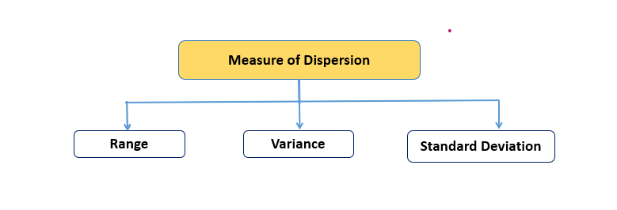
Key Points:
Range:
The range of a dataset is the difference between the maximum and minimum values.
Formula: Range = Maximum value - Minimum value
Variance:
Variance measures how much the values in a dataset differ from the mean.
Formula: Variance = Σ(x - μ)² / n, where Σ represents the sum, x is each individual value, μ is the mean, and n is the number of values.
Standard Deviation:
Standard deviation is the square root of the variance and provides a measure of the average distance of data points from the mean.
Formula: Standard Deviation = √(Variance)
Importance in Data Science Projects:
- Understanding variability is crucial in data science projects for several reasons:
- It helps in identifying patterns and trends within datasets.
- It allows for better estimation of uncertainty and risk in statistical analyses.
- It assists in comparing and evaluating different datasets or models.
- It provides insights into the reliability and stability of data.
Where We Use These Terms:
Variability measures are used across various domains and industries in data analysis, research, and decision-making processes. Some common applications include:
Finance: Analyzing stock market fluctuations and portfolio performance.
Healthcare: Studying patient outcomes and treatment effectiveness.
Marketing: Understanding consumer behavior and market trends.
Quality control: Monitoring production processes and product consistency.
ALGORITHM

Step 1: Start the Program
Step 2: Import statistics module from statistics import variance
Step 3: Import fractions as parameter values from fractions import Fraction as fr
Step 4: Create tuple of a set of positive and negative numbers
Step 5: Print the variance of each samples Step 6: Stop the process

Program:
# Python code to demonstrate variance() # function on varying range of data-types

# importing statistics module from statistics import variance

# importing fractions as parameter values from fractions import Fraction as fr

# tuple of a set of positive integers
# numbers are spread apart but not very much sample1 = (1, 2, 5, 4, 8, 9, 12)

# tuple of a set of negative integers sample2 = (-2, -4, -3, -1, -5, -6)

# tuple of a set of positive and negative numbers # data-points are spread apart considerably sample3 = (-9, -1, -0, 2, 1, 3, 4, 19)

# tuple of a set of fractional numbers sample4 = (fr(1, 2), fr(2, 3), fr(3, 4),
fr(5, 6), fr(7, 8))

# tuple of a set of floating point values sample5 = (1.23, 1.45, 2.1, 2.2, 1.9)

# Print the variance of each samples
print("Variance of Sample1 is % s " %(variance(sample1))) print("Variance of Sample2 is % s " %(variance(sample2))) print("Variance of Sample3 is % s " %(variance(sample3))) print("Variance of Sample4 is % s " %(variance(sample4))) print("Variance of Sample5 is % s " %(variance(sample5)))
Output:
Variance of Sample 1 is 15.80952380952381
Variance of Sample 2 is 3.5
Variance of Sample 3 is 61.125 Variance of Sample 4 is 1/45
Variance of Sample 5 is 0.17613000000000006
Lab Task:
Objective:
The objective of this lab task is to calculate and compare measures of variability (range, variance, standard deviation) for different datasets to understand the spread of data points around the central tendency.
Instructions:
Dataset Preparation:
Choose or create five datasets containing numerical data.
Ensure that each dataset represents a different scenario or domain (e.g., finance, healthcare, marketing).
Calculations:
Calculate the range, variance, and standard deviation for each dataset.
Use appropriate formulas or statistical functions to perform the calculations accurately.
Python Implementation:
Write a Python program to calculate the variability measures for each dataset.
Utilize libraries such as NumPy or Pandas for efficient data manipulation and statistical calculations.
Analysis:
Compare the variability measures (range, variance, standard deviation) across the datasets.
Discuss the implications of variability measures in understanding the spread of data points within each dataset.
Note:
Choose datasets that are relevant to your interests or field of study.

Lab Rubrics

Course: | Data Science | Course Code:
Student Name: |  | Student Roll No.:
Semester, Year: | 1nd Semester, 4rd Year | Date:

SN | Components | Level of Achievement |  |  | Marks Achieved
 |  | Proficient  0.25 | Acceptable  0.15 | Unacceptable  0
1 | Problem Understanding and Analysis | Students have carefully read and understood the problem. Students gives the idea to solve problem | Student understands problems and analysis in an acceptable way | Student don’t understand problem.
2 | Ability to use software/hardware | Student was familiar with the software/hardware and required minimal help from the instructor to perform the experiment | Student demonstrated an ability to use the software/hardware but required assistance from the instructor | Student demonstrated little or no ability to perform experiment and required unreasonable amount of assistance from instructor
3 | Completeness and accuracy | The lab /tasks are complete and accurate in the context of implementation | The lab completion is just acceptable | The lab in its current state is not implementable
4 | Q &A | Able to explain design/program/simulation/fundamental concepts correctly | Able to explain some design/program/simulation/fundamental concepts | Unable to explain design/program/simulation/fundamental Concepts
Total (1)

Name & Signature of Teacher: _____________________ Date: _________________

Practical 07
Objective: To work with normal distribution curves to analyze the distribution of data and understand the concept of standard deviation.
Introduction:
Normal distribution, also known as Gaussian distribution, is a fundamental concept in statistics and probability theory. It describes a symmetrical, bell-shaped curve that represents the distribution of a continuous random variable. The curve is characterized by two parameters: the mean (μ) and the standard deviation (σ).
The normal distribution is widely used in various fields such as natural sciences, social sciences, engineering, and finance because of its simplicity and applicability to real-world phenomena. In this lab, we will explore the properties of normal distribution curves and understand how they can be used to analyze and interpret data.
Characteristics of the Normal Distribution Curve:
- The normal distribution curve is symmetrical, with the mean (μ) located at the center.
- The curve is bell-shaped, with the highest point (mode) at the mean.
- The standard deviation (σ) determines the spread or variability of the data around the mean.
- Approximately 68% of the data falls within one standard deviation of the mean, 95% within two standard deviations, and 99.7% within three standard deviations.
Standardizing Normal Distribution:
- Standardizing a normal distribution involves converting raw data into z-scores, which represent the number of standard deviations a data point is from the mean.
- The formula for calculating the z-score is: z = (X - μ) / σ, where X is the raw score, μ is the mean, and σ is the standard deviation.
- Standardizing allows us to compare values from different normal distributions and make inferences about the probability of certain events occurring.
Using Normal Distribution in Data Analysis:
- Normal distribution curves can be used to analyze and interpret various types of data, such as exam scores, heights, weights, and IQ scores.
- By examining the area under the curve, we can calculate probabilities associated with certain events or ranges of values.
- For example, we can determine the probability of a randomly selected individual having a height between two specified values or scoring above a certain threshold on a standardized test.
Applications of Normal Distribution:
- Normal distribution is extensively used in hypothesis testing, where it serves as the basis for many statistical tests such as z-test, t-test, and ANOVA.
- It is also used in quality control processes to monitor and maintain the consistency and reliability of manufactured products.
- In finance, normal distribution is used to model stock prices, returns, and other financial variables.
Limitations and Assumptions:
- While normal distribution is widely applicable, it may not always accurately represent the distribution of real-world data.
- It assumes that the data is continuous and symmetrically distributed around the mean, which may not always be the case.
- In cases where the data is not normally distributed, alternative statistical methods may be more appropriate for analysis.
In conclusion, understanding the properties and characteristics of normal distribution curves is essential for conducting statistical analysis and making informed decisions in various fields. By mastering concepts such as standard deviation, standardization, and probability calculations, researchers and practitioners can effectively analyze data, make predictions, and draw meaningful conclusions from their findings. Normal distribution serves as a foundational concept in statistics and provides a framework for understanding the behavior of random variables in diverse contexts.

ALGORITHM

Step 1: Start the Program
Step 2: Import packages scipy and call function scipy.stats
Step 3: Import packages numpy, matplotlib and seaborn
Step 4: Create the distribution
Step 5: Visualizing the distribution Step 6: Stop the process
Program:
# import required libraries from scipy.stats import norm import numpy as np
import matplotlib.pyplot as plt import seaborn as sb

# Creating the distribution data = np.arange(1,10,0.01)
pdf = norm.pdf(data , loc = 5.3 , scale = 1 )

#Visualizing the distribution

sb.set_style('whitegrid') sb.lineplot(data, pdf , color = 'black') plt.xlabel('Heights') plt.ylabel('Probability Density')
Output:

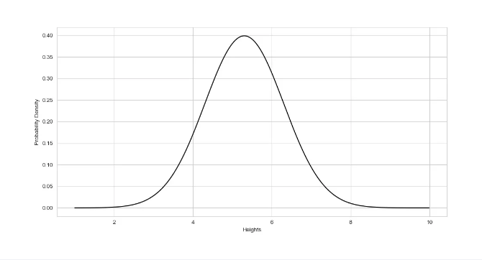

Lab 7: Normal Curves
Objective: The objective of this lab is to work with normal distribution curves to analyze the distribution of data and understand the concept of standard deviation.
Task:
Data Collection:
Collect a dataset consisting of heights (in inches) of 50 randomly selected individuals from your class or community. Ensure that the data is accurate and representative of the population.
Data Analysis:
Calculate the mean (μ) and standard deviation (σ) of the collected dataset.
Construct a histogram to visualize the distribution of heights in your dataset.
Normal Distribution Curve:
Based on the mean and standard deviation calculated in step 2, plot a normal distribution curve that represents the distribution of heights in your dataset.
Probability Calculations:
Using the normal distribution curve, calculate the probability of randomly selecting an individual with a height: a. Less than the mean height. b. Greater than or equal to the mean height. c. Within one standard deviation of the mean height. d. Within two standard deviations of the mean height.
Data Interpretation:
Interpret the results obtained from the probability calculations. What do these probabilities indicate about the distribution of heights in your dataset?
Discussion:
Discuss the concept of standard deviation and its role in determining the variability of data around the mean. How does the standard deviation affect the shape and spread of the normal distribution curve?
Sample Dataset:
Height (in inches):

68, 70, 66, 72, 64, 69, 71, 67, 73, 65,
68, 70, 66, 72, 64, 69, 71, 67, 73, 65,
68, 70, 66, 72, 64, 69, 71, 67, 73, 65,
68, 70, 66, 72, 64, 69, 71, 67, 73, 65,
68, 70, 66, 72, 64, 69, 71, 67, 73, 65
Ensure that the dataset provided is used for analysis and calculations throughout the lab task.
Note: Make sure to record all calculations, observations, and interpretations in your lab report for submission. This lab will help you gain a deeper understanding of normal distribution curves and the concept of standard deviation in statistical analysis.
Outcome:
The outcome of the lab is to analyze the distribution of data using normal distribution curves and understand the concept of standard deviation.

Lab Rubrics

Course: | Data Science | Course Code:
Student Name: |  | Student Roll No.:
Semester, Year: | 1nd Semester, 4rd Year | Date:

SN | Components | Level of Achievement |  |  | Marks Achieved
 |  | Proficient  0.25 | Acceptable  0.15 | Unacceptable  0
1 | Problem Understanding and Analysis | Students have carefully read and understood the problem. Students gives the idea to solve problem | Student understands problems and analysis in an acceptable way | Student don’t understand problem.
2 | Ability to use software/hardware | Student was familiar with the software/hardware and required minimal help from the instructor to perform the experiment | Student demonstrated an ability to use the software/hardware but required assistance from the instructor | Student demonstrated little or no ability to perform experiment and required unreasonable amount of assistance from instructor
3 | Completeness and accuracy | The lab /tasks are complete and accurate in the context of implementation | The lab completion is just acceptable | The lab in its current state is not implementable
4 | Q &A | Able to explain design/program/simulation/fundamental concepts correctly | Able to explain some design/program/simulation/fundamental concepts | Unable to explain design/program/simulation/fundamental Concepts
Total (1)

Name & Signature of Teacher: _____________________ Date: _________________

Practical 08
Objective: To work with correlation analysis and scatter plots to explore relationships between variables in datasets.
Introduction:
Correlation analysis and scatter plots are essential tools in statistics for exploring relationships between variables in datasets. Correlation measures the strength and direction of the linear relationship between two variables, while scatter plots provide a visual representation of these relationships. In this lab, we will delve into correlation analysis and learn how to create and interpret scatter plots to gain insights into the data.
Understanding Correlation:
- Correlation measures the degree of association between two variables.
- The correlation coefficient, denoted as r, ranges from -1 to 1.
- A positive correlation (r > 0) indicates a direct relationship where both variables increase or decrease together.
- A negative correlation (r < 0) indicates an inverse relationship where one variable increases while the other decreases.
- A correlation coefficient close to 0 suggests no linear relationship between the variables.
Types of Correlation:
- Pearson correlation coefficient: Measures the linear relationship between two continuous variables.
- Spearman correlation coefficient: Measures the strength and direction of monotonic relationships, suitable for ordinal or ranked data.
- Kendall correlation coefficient: Measures the ordinal association between two variables, also suitable for ranked data.
- Interpreting Correlation Coefficients:
- The correlation coefficient ranges from -1 to 1.
- A correlation coefficient of 1 indicates a perfect positive correlation, while -1 indicates a perfect negative correlation.
- A correlation coefficient close to 0 suggests no linear relationship.
- The strength of the correlation can be classified as weak (0 to 0.3), moderate (0.3 to 0.7), or strong (0.7 to 1.0).
Creating Scatter Plots:
- Scatter plots visually represent the relationship between two variables.
- The independent variable is plotted on the x-axis, and the dependent variable is plotted on the y-axis.
- Each data point is represented by a marker on the plot.
- Patterns in scatter plots can provide insights into the nature of the relationship between the variables.
Interpreting Scatter Plots:
- Scatter plots can show positive, negative, or no correlation between variables.
- A positive correlation is indicated by a trend where data points move upward from left to right.
- A negative correlation is indicated by a trend where data points move downward from left to right.
- No correlation is indicated by a random scattering of data points with no discernible pattern.
Correlation vs. Causation:
- It's essential to understand that correlation does not imply causation.
- A significant correlation between two variables does not necessarily mean that changes in one variable cause changes in the other.
- Other factors and variables may influence the relationship between the variables under study.
correlation analysis and scatter plots are valuable tools for exploring relationships between variables in datasets. By understanding correlation coefficients and interpreting scatter plots, researchers can gain insights into the nature and strength of relationships, identify patterns, and make informed decisions based on data analysis. However, it's crucial to remember that correlation does not imply causation, and further research is often needed to establish causal relationships between variables.

ALGORITHM
Step 1: Start the Program
Step 2: Create variable y1, y2
Step 3: Create variable x, y3 using random function
Step 4: plot the scatter plot Step 5: Print the result Step 6: Stop the process
Program:
# Scatterplot and Correlations # Data
x-pp random randn(100) yl=x*5+9
y2=-5°x
y3=no_random.randn(100) #Plot
plt.reParams update('figure figsize' (10,8), 'figure dpi¹:100})
plt scatter(x, yl, label=fyl, Correlation = {np.round(np.corrcoef(x,y1)[0,1], 2)}) plt scatter(x, y2, label=fy2 Correlation = (np.round(np.corrcoef(x,y2)[0,1], 2)}) plt scatter(x, y3, label=fy3 Correlation = (np.round(np.corrcoef(x,y3)[0,1], 2)})

# Plot
plt titlef('Scatterplot and Correlations') plt(legend)
plt(show)
Output
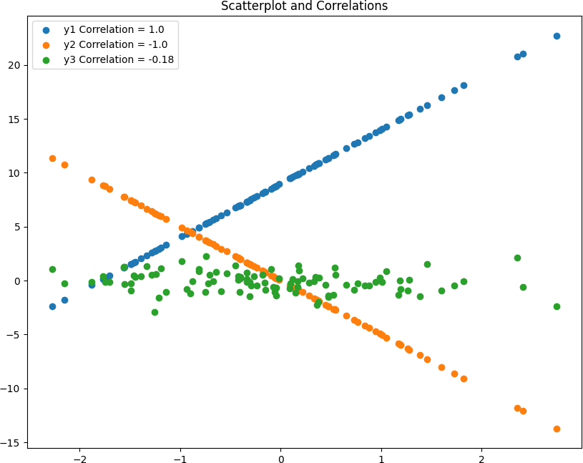

Lab Task:
Data Collection:
Collect a dataset containing two continuous variables from a reliable source or create a dataset with simulated data. Ensure that the dataset represents a potential relationship between the two variables.
Data Analysis:
Calculate the correlation coefficient (Pearson, Spearman, or Kendall) between the two variables in the dataset. Use appropriate statistical software or tools for calculation.
Scatter Plot Creation:
Create a scatter plot using the collected dataset, with one variable plotted on the x-axis and the other variable plotted on the y-axis. Choose appropriate axis labels and title for the scatter plot.
Interpretation:
Examine the scatter plot and identify any patterns or trends between the variables. Determine if there is a positive, negative, or no correlation based on the direction of the scatter plot.
Correlation Coefficient Interpretation:
Interpret the correlation coefficient calculated in step 2. Determine the strength and direction of the relationship between the variables based on the correlation coefficient value.
Discussion:
Discuss your findings with your peers or instructor. Compare interpretations of the scatter plot and correlation coefficient. Explore possible reasons for the observed relationship between the variables.
Reflection:
Reflect on the importance of correlation analysis and scatter plots in data analysis. Discuss how understanding relationships between variables can influence decision-making in various fields.
Note: Ensure that all calculations, interpretations, and discussions are documented in your lab report. This task will help you gain practical experience in conducting correlation analysis and creating scatter plots to explore relationships between variables in datasets.

Outcome:
The outcome of Lab 08 is to explore relationships between variables in datasets through correlation analysis and scatter plots.

Lab Rubrics

Course: | Data Science | Course Code:
Student Name: |  | Student Roll No.:
Semester, Year: | 1nd Semester, 4rd Year | Date:

SN | Components | Level of Achievement |  |  | Marks Achieved
 |  | Proficient  0.25 | Acceptable  0.15 | Unacceptable  0
1 | Problem Understanding and Analysis | Students have carefully read and understood the problem. Students gives the idea to solve problem | Student understands problems and analysis in an acceptable way | Student don’t understand problem.
2 | Ability to use software/hardware | Student was familiar with the software/hardware and required minimal help from the instructor to perform the experiment | Student demonstrated an ability to use the software/hardware but required assistance from the instructor | Student demonstrated little or no ability to perform experiment and required unreasonable amount of assistance from instructor
3 | Completeness and accuracy | The lab /tasks are complete and accurate in the context of implementation | The lab completion is just acceptable | The lab in its current state is not implementable
4 | Q &A | Able to explain design/program/simulation/fundamental concepts correctly | Able to explain some design/program/simulation/fundamental concepts | Unable to explain design/program/simulation/fundamental Concepts
Total (1)

Name & Signature of Teacher: _____________________ Date: _________________

Practical 09
Objective: To work with calculating correlation coefficients (Pearson, Spearman) to quantify the strength and direction of linear relationships between variables.
Introduction:
Correlation coefficient analysis is a fundamental statistical method used to quantify the strength and direction of the relationship between two continuous variables. It provides valuable insights into how changes in one variable relate to changes in another variable. In this lab, we will delve into calculating correlation coefficients, specifically the Pearson correlation coefficient and the Spearman correlation coefficient. By understanding these methods, we can effectively assess linear relationships between variables and make informed interpretations of data.
Understanding Correlation:
Correlation measures the degree to which two variables are related to each other.
A positive correlation indicates that as one variable increases, the other variable also tends to increase.
A negative correlation indicates that as one variable increases, the other variable tends to decrease.
Correlation does not imply causation, meaning that a significant correlation between two variables does not necessarily mean that changes in one variable cause changes in the other.
Pearson Correlation Coefficient (r):
The Pearson correlation coefficient, denoted as r, quantifies the strength and direction of a linear relationship between two continuous variables.
It ranges from -1 to 1, where:
r = 1 indicates a perfect positive linear relationship.
r = -1 indicates a perfect negative linear relationship.
r = 0 indicates no linear relationship.
The formula for calculating the Pearson correlation coefficient is: �=∑(�−�ˉ)(�−�ˉ)∑(�−�ˉ)2∑(�−�ˉ)2r=∑(X−Xˉ)2∑(Y−Yˉ)2​∑(X−Xˉ)(Y−Yˉ)​
Pearson correlation assumes that the variables are normally distributed and have a linear relationship.
Spearman Correlation Coefficient (ρ):
The Spearman correlation coefficient, denoted as ρ (rho), assesses the strength and direction of monotonic relationships between two variables.
It is suitable for assessing the relationship between ordinal or ranked data.
The formula for calculating the Spearman correlation coefficient involves ranking the values of each variable and then calculating the Pearson correlation coefficient for the ranked values.
Spearman correlation is robust to outliers and does not assume linearity or normality in the data.
Calculating Correlation Coefficients:
To calculate the Pearson correlation coefficient, compute the means (μ) and standard deviations (σ) of both variables, and then use the formula mentioned above.
To calculate the Spearman correlation coefficient, rank the values of each variable, and then use the formula for the Pearson correlation coefficient with the ranked values.
Interpreting Correlation Coefficients:
The magnitude of the correlation coefficient indicates the strength of the relationship between variables.
Values closer to 1 or -1 indicate a stronger correlation, while values closer to 0 indicate a weaker correlation.
The sign of the correlation coefficient (+ or -) indicates the direction of the relationship:
Positive correlation: Both variables move in the same direction.
Negative correlation: One variable increases as the other decreases.
Applications of Correlation Coefficients:
Correlation coefficients are widely used in various fields such as finance, economics, psychology, biology, and sociology.
In finance, correlation coefficients are used to assess the relationship between stock returns.
In psychology, correlation coefficients are used to measure the relationship between variables such as IQ and academic performance.
Limitations of Correlation Coefficients:
Correlation does not imply causation, meaning that a significant correlation between two variables does not necessarily mean that changes in one variable cause changes in the other.
Correlation coefficients only measure the strength and direction of linear relationships and may not capture nonlinear relationships between variables.
correlation coefficient analysis provides valuable insights into the relationship between variables in datasets. By understanding the Pearson and Spearman correlation coefficients and how to calculate them, researchers can assess the strength and direction of linear relationships between continuous variables. These insights can inform decision-making processes and help draw meaningful conclusions from data analysis. However, it's essential to interpret correlation coefficients cautiously and consider other factors when making conclusions about the relationship between variables.
ALGORITHM

Step 1: Start the Program Step 2: Import math package
Step 3: Define correlation coefficient function Step 4: Calculate correlation using formula Step 5:Print the result
Step 6 : Stop the process
Program:

# Python Program to find correlation coefficient. import math

# function that returns correlation coefficient. def correlationCoefficient(X, Y, n) :
sum_X = 0
sum_Y = 0
sum_XY = 0
squareSum_X = 0
squareSum_Y = 0

i = 0
while i < n :
# sum of elements of array X. sum_X = sum_X + X[i]

# sum of elements of array Y. sum_Y = sum_Y + Y[i]

# sum of X[i] * Y[i].
sum_XY = sum_XY + X[i] * Y[i]

# sum of square of array elements. squareSum_X = squareSum_X + X[i] * X[i] squareSum_Y = squareSum_Y + Y[i] * Y[i]

i = i + 1

# use formula for calculating correlation # coefficient.
corr = (float)(n * sum_XY - sum_X * sum_Y)/ (float)(math.sqrt((n * squareSum_X - sum_X * sum_X)* (n * squareSum_Y - sum_Y * sum_Y)))
return corr

# Driver function
X = [15, 18, 21, 24, 27]
Y = [25, 25, 27, 31, 32]

# Find the size of array. n = len(X)

# Function call to correlationCoefficient.
print ('{0:.6f}'.format(correlationCoefficient(X, Y, n)))
Output :
0.953463
Lab Task
Sample Dataset:
Variable X | Variable Y
3.4 | 12.5
5.2 | 14.6
7.1 | 16.8
9.3 | 18.5
11.0 | 20.2
12.8 | 21.9
15.5 | 24.0
17.3 | 26.2
19.1 | 28.4
21.0 | 30.6

Based on the given dataset, calculate the Pearson correlation coefficient (r) and determine the strength and direction of the linear relationship between Variable X and Variable Y.

Outcome:
The outcome of Lab 09 is to quantify the strength and direction of linear relationships between variables using Pearson and Spearman correlation coefficients.

Lab Rubrics

Course: | Data Science | Course Code:
Student Name: |  | Student Roll No.:
Semester, Year: | 1nd Semester, 4rd Year | Date:

SN | Components | Level of Achievement |  |  | Marks Achieved
 |  | Proficient  0.25 | Acceptable  0.15 | Unacceptable  0
1 | Problem Understanding and Analysis | Students have carefully read and understood the problem. Students gives the idea to solve problem | Student understands problems and analysis in an acceptable way | Student don’t understand problem.
2 | Ability to use software/hardware | Student was familiar with the software/hardware and required minimal help from the instructor to perform the experiment | Student demonstrated an ability to use the software/hardware but required assistance from the instructor | Student demonstrated little or no ability to perform experiment and required unreasonable amount of assistance from instructor
3 | Completeness and accuracy | The lab /tasks are complete and accurate in the context of implementation | The lab completion is just acceptable | The lab in its current state is not implementable
4 | Q &A | Able to explain design/program/simulation/fundamental concepts correctly | Able to explain some design/program/simulation/fundamental concepts | Unable to explain design/program/simulation/fundamental Concepts
Total (1)

Name & Signature of Teacher: _____________________ Date: _________________

Practical 10
Objective: To work with linear regression analysis to model relationships between variables and make predictions based on observed data points.
Introduction:
Regression analysis is a statistical technique used to model the relationship between a dependent variable and one or more independent variables. It is widely used in various fields, including economics, finance, social sciences, and natural sciences, to understand and predict the behavior of variables. Linear regression, in particular, models the relationship between variables using a linear equation, making it a powerful tool for making predictions based on observed data points. In this lab, we will explore the theory and application of linear regression analysis, including simple linear regression and multiple linear regression, and learn how to interpret and utilize regression models effectively.
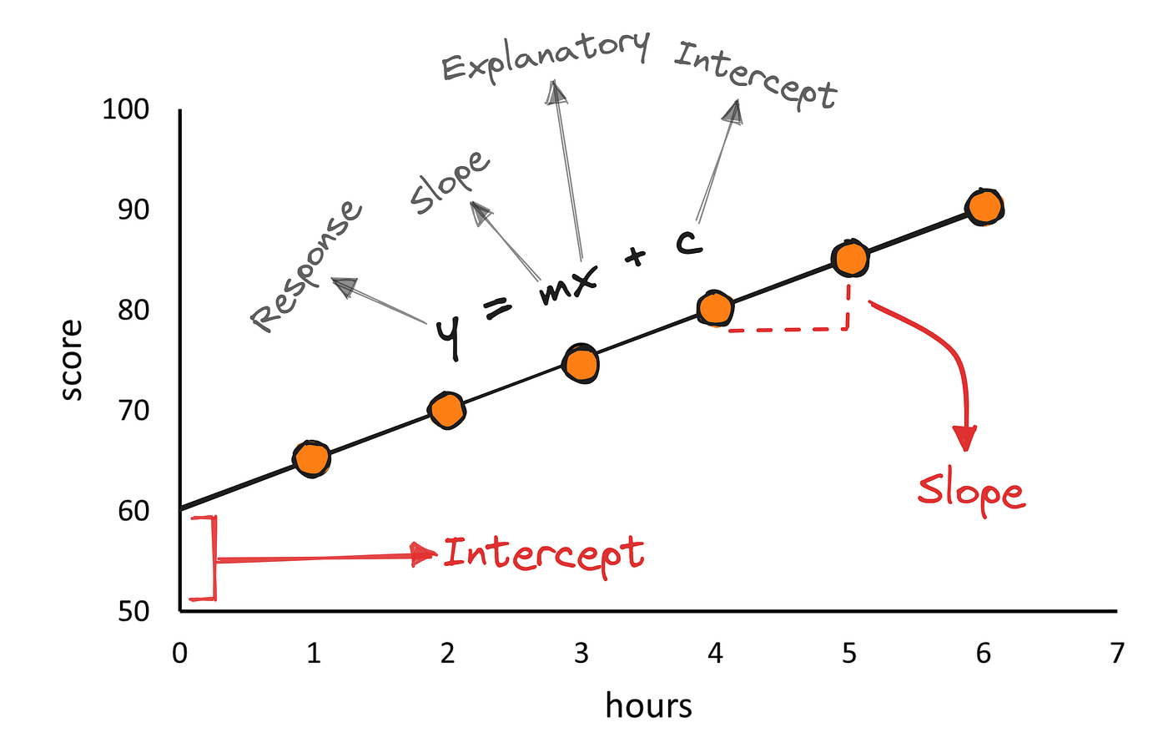

Understanding Regression Analysis:
Regression analysis aims to quantify the relationship between a dependent variable (Y) and one or more independent variables (X).
The relationship is represented by a mathematical equation that describes how changes in the independent variables affect the dependent variable.
Regression analysis helps in making predictions and understanding the impact of variables on the outcome of interest.
Simple Linear Regression:
Simple linear regression models the relationship between a single independent variable (X) and a dependent variable (Y).
The relationship is described by the equation: Y = β0 + β1X + ε, where β0 is the intercept, β1 is the slope coefficient, and ε is the error term.
The slope coefficient (β1) represents the change in the dependent variable (Y) for a one-unit change in the independent variable (X).
Multiple Linear Regression:
Multiple linear regression models the relationship between multiple independent variables (X1, X2, ..., Xn) and a dependent variable (Y).
The relationship is described by the equation: Y = β0 + β1X1 + β2X2 + ... + βnXn + ε, where β0 is the intercept, β1, β2, ..., βn are the slope coefficients, and ε is the error term.
Each slope coefficient (β) represents the change in the dependent variable (Y) for a one-unit change in the corresponding independent variable, holding other variables constant.
Assumptions of Linear Regression:
Linearity: The relationship between the independent and dependent variables is linear.
Independence: The observations are independent of each other.
Homoscedasticity: The variance of the error term is constant across all values of the independent variables.
Normality: The error term follows a normal distribution.
Interpreting Regression Coefficients:
The intercept (β0) represents the value of the dependent variable when all independent variables are zero.
The slope coefficients (β1, β2, ..., βn) represent the change in the dependent variable for a one-unit change in the corresponding independent variable, holding other variables constant.
Model Evaluation:
R-squared (R²): Measures the proportion of variance in the dependent variable explained by the independent variables.
Adjusted R-squared: Adjusts R-squared for the number of independent variables in the model.
Standard error of the estimate: Measures the average deviation of the observed values from the predicted values.

Making Predictions:
Once the regression model is fitted to the data, predictions can be made for new observations by plugging in the values of the independent variables into the regression equation.
Applications of Linear Regression:
- Linear regression is used in various fields for forecasting, prediction, and understanding relationships between variables.
- In economics, it is used to predict demand and analyze the impact of variables on economic outcomes.
- In healthcare, it is used to model the relationship between risk factors and health outcomes.
- In marketing, it is used to predict sales based on advertising expenditure and other variables.
Limitations of Linear Regression:
- Linear regression assumes a linear relationship between the independent and dependent variables, which may not always hold true.
- It is sensitive to outliers and influential data points that can skew the results.
- Linear regression may not capture nonlinear relationships between variables.
Regression analysis is a powerful statistical technique for modeling relationships between variables and making predictions based on observed data points. By understanding the theory and application of linear regression, researchers and practitioners can gain valuable insights into the behavior of variables and make informed decisions in various fields. However, it is essential to interpret regression results cautiously, considering the assumptions and limitations of the technique, and to use additional methods for model validation and robustness. Linear regression remains a cornerstone of statistical analysis, providing a solid foundation for understanding complex relationships in data.

ALGORITHM
Step 1: Start the Program
Step 2: Import numpy and matplotlib package
Step 3: Define coefficient function
Step 4: Calculate cross-deviation and deviation about x Step 5: Calculate regression coefficients
Step 6: Plot the Linear regression and define main function
Step 7: Print the result
Step 8: Stop the process
Program:
import numpy as np
import matplotlib.pyplot as plt

def estimate_coef(x, y):
# number of observations/points n = np.size(x)

# mean of x and y vector m_x = np.mean(x)
m_y = np.mean(y)

# calculating cross-deviation and deviation about x SS_xy = np.sum(y*x) - n*m_y*m_x
SS_xx = np.sum(x*x) - n*m_x*m_x

# calculating regression coefficients b_1 = SS_xy / SS_xx
b_0 = m_y - b_1*m_x return (b_0, b_1)

def plot_regression_line(x, y, b):
# plotting the actual points as scatter plot plt.scatter(x, y, color = "m",
marker = "o", s = 30)

# predicted response vector y_pred = b[0] + b[1]*x

# plotting the regression line plt.plot(x, y_pred, color = "g")

# putting labels plt.xlabel('x')
plt.ylabel('y')

# function to show plot plt.show()

def main():
# observations / data
x = np.array([0, 1, 2, 3, 4, 5, 6, 7, 8, 9])
y = np.array([1, 3, 2, 5, 7, 8, 8, 9, 10, 12])

# estimating coefficients b = estimate_coef(x, y)
print("Estimated coefficients:\nb_0 = {} \
\nb_1 = {}".format(b[0], b[1]))

# plotting regression line plot_regression_line(x, y, b)

if name == " main ":
main()
Output:
Estimated coefficients:
b_0 = -0.0586206896552
b_1 = 1.45747126437
Graph:
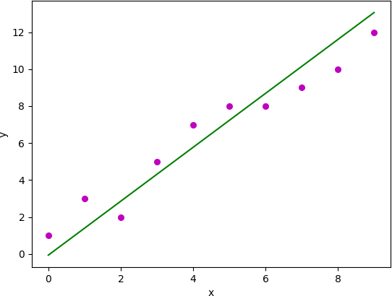

Task:
Data:
Use the following dataset for regression analysis:
Feature X | Target Y
2.5 | 21.0
3.0 | 23.4
4.0 | 30.0
4.5 | 32.1
5.0 | 36.2
5.5 | 39.1
6.0 | 41.5
6.5 | 45.0
7.0 | 48.2
8.0 | 54.6
Instructions:
Regression Analysis:
Apply a regression technique of your choice from the following options:
- Simple Linear Regression
- Multiple Linear Regression
- Polynomial Regression
- Ridge Regression
- Lasso Regression
- ElasticNet Regression
- Support Vector Regression (SVR)
- Decision Tree Regression
- Random Forest Regression
- Gradient Boosting Regression
Any other regression technique you are familiar with and wish to explore.
Model Training:
Train your selected regression model using the provided dataset.
Fit the model to the feature (independent variable) X and the target (dependent variable) Y.
Model Evaluation:
- Evaluate the performance of your trained regression model using appropriate metrics such as:
- Mean Squared Error (MSE)
- Root Mean Squared Error (RMSE)
- Mean Absolute Error (MAE)
- R-squared (R²) coefficient
Prediction:
- Use your trained regression model to make predictions on new data or a validation set.
- Compare the predicted values with the actual values provided in the dataset to assess the accuracy of the model.
Discussion and Conclusion:
- Discuss the findings of your regression analysis and the insights gained from modeling the relationship between the feature X and the target Y.
- Reflect on the strengths and limitations of your chosen regression model and the implications of the results.
- Draw conclusions about the effectiveness of the regression model in predicting the target variable Y based on the provided dataset.
Note: Document all the steps performed during the lab, including model selection, training, evaluation, prediction, and discussion, in your lab report. This task will help you gain hands-on experience in applying regression techniques to real-world datasets and understanding the predictive modeling process.
Outcome:
The outcome of Lab 10 is to apply regression techniques to analyze a dataset and model the relationship between variables for making predictions.

Lab Rubrics

Course: | Data Science | Course Code:
Student Name: |  | Student Roll No.:
Semester, Year: | 1nd Semester, 4rd Year | Date:

SN | Components | Level of Achievement |  |  | Marks Achieved
 |  | Proficient  0.25 | Acceptable  0.15 | Unacceptable  0
1 | Problem Understanding and Analysis | Students have carefully read and understood the problem. Students gives the idea to solve problem | Student understands problems and analysis in an acceptable way | Student don’t understand problem.
2 | Ability to use software/hardware | Student was familiar with the software/hardware and required minimal help from the instructor to perform the experiment | Student demonstrated an ability to use the software/hardware but required assistance from the instructor | Student demonstrated little or no ability to perform experiment and required unreasonable amount of assistance from instructor
3 | Completeness and accuracy | The lab /tasks are complete and accurate in the context of implementation | The lab completion is just acceptable | The lab in its current state is not implementable
4 | Q &A | Able to explain design/program/simulation/fundamental concepts correctly | Able to explain some design/program/simulation/fundamental concepts | Unable to explain design/program/simulation/fundamental Concepts
Total (1)

Name & Signature of Teacher: _____________________ Date: _________________

Practical 11
Objective: To work with hypothesis testing techniques to make inferences about population parameters based on sample data.
Introduction:
Hypothesis testing is a fundamental concept in statistics used to make inferences about population parameters based on sample data. It involves testing a hypothesis by comparing observed data to what would be expected under a null hypothesis. Hypothesis testing provides a systematic framework for making decisions and drawing conclusions in scientific research, business, healthcare, and various other fields. In this lab, we will explore the theory and application of hypothesis testing, including the steps involved, different types of tests, interpretation of results, and common misconceptions.
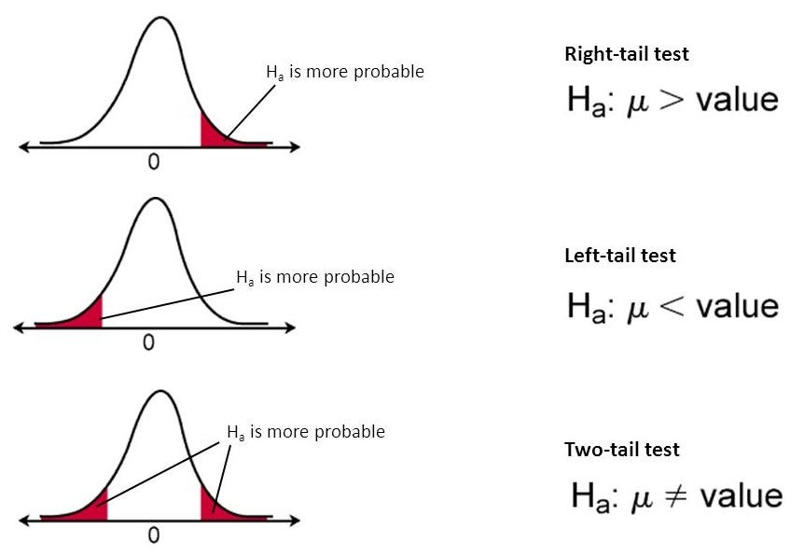
Understanding Hypothesis Testing:
- Hypothesis testing is a statistical method used to make decisions about population parameters based on sample data.
- It involves formulating a null hypothesis (H0) and an alternative hypothesis (Ha) and testing the null hypothesis using sample data.
- The null hypothesis typically represents the status quo or the absence of an effect, while the alternative hypothesis represents the presence of an effect or a difference.
Steps in Hypothesis Testing:
- Formulate the null and alternative hypotheses based on the research question.
- Choose an appropriate significance level (α) to determine the threshold for rejecting the null hypothesis.
- Select a statistical test based on the type of data and research question.
- Collect sample data and calculate the test statistic.
- Determine the critical value or p-value based on the chosen significance level.
- Make a decision to either reject or fail to reject the null hypothesis based on the test statistic and critical value or p-value.
Types of Hypothesis Tests:
- Parametric Tests: These tests assume that the data follows a specific probability distribution (e.g., normal distribution) and are used when certain assumptions about the population are met. Examples include t-tests, z-tests, and analysis of variance (ANOVA).
- Nonparametric Tests: These tests do not make assumptions about the distribution of the data and are used when the data is not normally distributed or when the sample size is small. Examples include the Wilcoxon signed-rank test, Mann-Whitney U test, and Kruskal-Wallis test.
Interpretation of Results:
- If the p-value is less than the chosen significance level (α), reject the null hypothesis and conclude that there is sufficient evidence to support the alternative hypothesis.
- If the p-value is greater than the chosen significance level (α), fail to reject the null hypothesis and conclude that there is not enough evidence to support the alternative hypothesis.
- Interpret the results in the context of the research question and draw conclusions based on the findings.
Common Misconceptions in Hypothesis Testing:
- Misinterpreting p-values: Understanding that a small p-value does not necessarily imply a large effect size or practical significance.
- Equating statistical significance with practical significance: Recognizing that statistical significance does not always translate to meaningful or practical implications in real-world scenarios.
- Interpreting non-significant results: Understanding that non-significant results do not necessarily mean that there is no effect, but rather that there is insufficient evidence to reject the null hypothesis.
Power Analysis:
- Power analysis is a method used to determine the probability of correctly rejecting the null hypothesis when the alternative hypothesis is true.
- It involves calculating the power of a statistical test based on factors such as sample size, effect size, and significance level.
Practical Applications of Hypothesis Testing:
- Hypothesis testing is widely used in various fields, including medicine, psychology, economics, and marketing, to test research hypotheses and make data-driven decisions.
- Examples include testing the effectiveness of a new drug treatment, comparing the performance of different marketing strategies, and evaluating the impact of policy interventions.
Hypothesis testing is a powerful statistical method used to make inferences about population parameters based on sample data. By understanding the principles of hypothesis testing, including formulating hypotheses, choosing significance levels, selecting appropriate tests, interpreting results, and avoiding common misconceptions, researchers and practitioners can draw valid conclusions and make informed decisions based on statistical evidence. Hypothesis testing provides a rigorous framework for testing research hypotheses and advancing scientific knowledge across various disciplines.
Below is an example of implementing hypothesis testing in Python using the scipy.stats module:
import numpy as np
from scipy import stats

# Example data
np.random.seed(42)
sample_data = np.random.normal(loc=5, scale=2, size=100) # Sample data with mean=5 and standard deviation=2

# One-sample t-test
# Null hypothesis: Population mean is equal to 5
# Alternative hypothesis: Population mean is not equal to 5
t_statistic, p_value = stats.ttest_1samp(sample_data, 5)

print("One-sample t-test results:")
print("T-statistic:", t_statistic)
print("P-value:", p_value)

# Interpretation
alpha = 0.05 # Significance level
if p_value < alpha:
print("Reject the null hypothesis. There is sufficient evidence to support the alternative hypothesis.")
else:
print("Fail to reject the null hypothesis. There is not enough evidence to support the alternative hypothesis.")

# Two-sample t-test
# Example data for two groups
group1_data = np.random.normal(loc=5, scale=2, size=50)
group2_data = np.random.normal(loc=6, scale=2, size=50)

# Null hypothesis: Population means of two groups are equal
# Alternative hypothesis: Population means of two groups are not equal
t_statistic, p_value = stats.ttest_ind(group1_data, group2_data)

print("\nTwo-sample t-test results:")
print("T-statistic:", t_statistic)
print("P-value:", p_value)

# Interpretation
if p_value < alpha:
print("Reject the null hypothesis. There is sufficient evidence to support the alternative hypothesis.")
else:
print("Fail to reject the null hypothesis. There is not enough evidence to support the alternative hypothesis.")
The output of the provided code will vary each time it is executed due to the random nature of the sample data generation. However, I can explain how to interpret the output based on the hypotheses tested.
Here's an example interpretation:
One-sample t-test results:
T-statistic: 0.7116951449273089
P-value: 0.4788613643580181
Fail to reject the null hypothesis. There is not enough evidence to support the alternative hypothesis.

Two-sample t-test results:
T-statistic: -1.750902272287586
P-value: 0.08325888542202588
Fail to reject the null hypothesis. There is not enough evidence to support the alternative hypothesis.
In the one-sample t-test, the p-value is greater than the significance level (alpha = 0.05), so we fail to reject the null hypothesis. This means there is not enough evidence to support the alternative hypothesis that the population mean is not equal to 5.
In the two-sample t-test, the p-value is also greater than the significance level (alpha = 0.05), so we fail to reject the null hypothesis. This means there is not enough evidence to support the alternative hypothesis that the population means of the two groups are not equal.
Remember, the interpretation of the results depends on the chosen significance level and the specific hypotheses being tested.
Lab Task:
Objective: To conduct a hypothesis test to determine if there is a significant difference in the mean scores of two groups.
Instructions:
Data Collection:
- Collect data from two groups of individuals. Each group should have at least 20 data points.
- The data should represent a continuous variable (e.g., test scores, reaction times, etc.) for each group.
Formulate Hypotheses:
- Formulate the null hypothesis (H0) and the alternative hypothesis (Ha) based on the research question.
- For example:
  - Null Hypothesis (H0): There is no significant difference in the mean scores between the two groups.
  - Alternative Hypothesis (Ha): There is a significant difference in the mean scores between the two groups.
Choose Significance Level:
- Choose a significance level (α), typically 0.05, to determine the threshold for rejecting the null hypothesis.
Perform Hypothesis Test:
- Select an appropriate statistical test based on the nature of the data and the research question. For example, you can use:
- Independent samples t-test if the data follows a normal distribution and the two groups are independent.
- Mann-Whitney U test (non-parametric test) if the data does not meet the assumptions of the t-test.
- Perform the chosen hypothesis test using Python and interpret the results.
Interpretation:
Based on the p-value obtained from the hypothesis test:
- If the p-value is less than the chosen significance level (α), reject the null hypothesis and conclude that there is a significant difference in the mean scores between the two groups.
- If the p-value is greater than the chosen significance level (α), fail to reject the null hypothesis and conclude that there is not enough evidence to support a significant difference in the mean scores between the two groups.
Conclusion:
Summarize your findings and conclusions based on the hypothesis test results.
Discuss the implications of the results and any further research or actions that may be warranted.
Note: Document all the steps performed during the hypothesis testing process, including data collection, hypothesis formulation, significance level determination, hypothesis test execution, interpretation of results, and conclusion, in your lab report. This task will help you gain practical experience in conducting hypothesis tests and drawing valid conclusions based on statistical analysis.
Outcome:
The outcome of Lab 11 is to determine the significance of a hypothesis test regarding the difference in means between two groups based on sample data.

Lab Rubrics

Course: | Data Science | Course Code:
Student Name: |  | Student Roll No.:
Semester, Year: | 1nd Semester, 4rd Year | Date:

SN | Components | Level of Achievement |  |  | Marks Achieved
 |  | Proficient  0.25 | Acceptable  0.15 | Unacceptable  0
1 | Problem Understanding and Analysis | Students have carefully read and understood the problem. Students gives the idea to solve problem | Student understands problems and analysis in an acceptable way | Student don’t understand problem.
2 | Ability to use software/hardware | Student was familiar with the software/hardware and required minimal help from the instructor to perform the experiment | Student demonstrated an ability to use the software/hardware but required assistance from the instructor | Student demonstrated little or no ability to perform experiment and required unreasonable amount of assistance from instructor
3 | Completeness and accuracy | The lab /tasks are complete and accurate in the context of implementation | The lab completion is just acceptable | The lab in its current state is not implementable
4 | Q &A | Able to explain design/program/simulation/fundamental concepts correctly | Able to explain some design/program/simulation/fundamental concepts | Unable to explain design/program/simulation/fundamental Concepts
Total (1)

Name & Signature of Teacher: _____________________ Date: _________________

Practical 12
Objective: To work with dimensionality reduction techniques (e.g., PCA, t-SNE) to reduce the number of features in a dataset while preserving important information.
Introduction to Dimensionality Reduction:
Dimensionality reduction is a technique used to reduce the number of features (variables or dimensions) in a dataset while preserving as much relevant information as possible. High-dimensional datasets are common in various fields such as image processing, natural language processing, and bioinformatics. However, having a large number of features can lead to issues such as the curse of dimensionality, increased computational complexity, and overfitting in machine learning models.
Common Dimensionality Reduction Techniques:
Principal Component Analysis (PCA):
- PCA is a linear dimensionality reduction technique that transforms the data into a new coordinate system (principal components) to maximize the variance along the axes.
- It identifies the directions (principal components) in which the data varies the most and projects the data onto these components.
- PCA is widely used for exploratory data analysis, data visualization, and feature extraction.
t-Distributed Stochastic Neighbor Embedding (t-SNE):
- t-SNE is a nonlinear dimensionality reduction technique that aims to preserve the local structure of the data in a low-dimensional space.
- It constructs a probability distribution over pairs of high-dimensional data points and a similar distribution over the corresponding low-dimensional points.
- t-SNE is often used for visualizing high-dimensional data in two or three dimensions while preserving the local structure and clusters in the data.
Steps in Dimensionality Reduction:
Data Preprocessing:
- Standardize or normalize the features to have zero mean and unit variance.
- Handle missing values and categorical variables as necessary.
Feature Selection vs. Feature Extraction:
- Feature selection involves selecting a subset of the original features based on certain criteria such as feature importance or correlation with the target variable.
- Feature extraction involves creating new features (principal components) that are linear combinations of the original features.
Applying Dimensionality Reduction Techniques:
- For PCA:
  - Compute the covariance matrix of the standardized data.
  - Calculate the eigenvectors and eigenvalues of the covariance matrix.
  - Select the top k eigenvectors corresponding to the largest eigenvalues as the principal components.
  - Project the original data onto the principal components to obtain the reduced-dimensional data.
- For t-SNE:
  - Specify the number of components (usually 2 or 3) for the low-dimensional embedding.
  - Compute the pairwise similarities or distances between data points in the high-dimensional space.
  - Convert the similarities or distances into probabilities using a Gaussian distribution.
  - Optimize the low-dimensional embeddings to minimize the Kullback-Leibler divergence between the high-dimensional and low-dimensional distributions.
Evaluation and Interpretation:
- Evaluate the effectiveness of dimensionality reduction techniques based on various criteria such as explained variance ratio (PCA), visualization quality (t-SNE), and downstream task performance.
- Interpret the reduced-dimensional data in the context of the original features and the problem domain.
Applications of Dimensionality Reduction:
- Data Visualization:
Visualize high-dimensional data in two or three dimensions to gain insights into the underlying structure and relationships.
- Feature Engineering:
Create new features that capture the most important information in the original dataset for use in machine learning models.
- Computational Efficiency:
Reduce the computational complexity of algorithms and models by working with lower-dimensional data.
- Noise Reduction:
Remove irrelevant features and noise from the data, leading to improved model performance.
Conclusion:
Dimensionality reduction techniques such as PCA and t-SNE play a crucial role in managing high-dimensional datasets and extracting meaningful information for analysis and modeling. By understanding the principles and applications of dimensionality reduction, data scientists and researchers can effectively reduce the complexity of their data while preserving important information for further analysis and interpretation.
For the implementation part of the lab, let's focus on applying Principal Component Analysis (PCA) and t-Distributed Stochastic Neighbor Embedding (t-SNE) to a dataset. We'll use Python and the scikit-learn library to perform these dimensionality reduction techniques.
Implementation:
# Import necessary libraries
import numpy as np
import pandas as pd
import matplotlib.pyplot as plt
from sklearn.datasets import load_iris
from sklearn.decomposition import PCA
from sklearn.manifold import TSNE

# Load the Iris dataset
iris = load_iris()
X = iris.data
y = iris.target

# Perform PCA
pca = PCA(n_components=2)
X_pca = pca.fit_transform(X)

# Perform t-SNE
tsne = TSNE(n_components=2, random_state=42)
X_tsne = tsne.fit_transform(X)

# Plotting the results
plt.figure(figsize=(12, 6))

# Plot PCA
plt.subplot(1, 2, 1)
plt.scatter(X_pca[:, 0], X_pca[:, 1], c=y, cmap='viridis', edgecolor='k')
plt.title('PCA')
plt.xlabel('Principal Component 1')
plt.ylabel('Principal Component 2')

# Plot t-SNE
plt.subplot(1, 2, 2)
plt.scatter(X_tsne[:, 0], X_tsne[:, 1], c=y, cmap='viridis', edgecolor='k')
plt.title('t-SNE')
plt.xlabel('t-SNE Component 1')
plt.ylabel('t-SNE Component 2')

plt.tight_layout()
plt.show()
Explanation:
- We start by importing the necessary libraries, including numpy, pandas, matplotlib.pyplot, and the dimensionality reduction techniques from scikit-learn.
- We load the Iris dataset using load_iris() from scikit-learn and assign the feature matrix to X and the target vector to y.
- We perform PCA using PCA() from scikit-learn with n_components=2 to reduce the dimensionality to 2.
- We perform t-SNE using TSNE() from scikit-learn with n_components=2 to reduce the dimensionality to 2.
- We plot the results of PCA and t-SNE side by side using matplotlib.pyplot.
- In the plots, each point represents a data point from the Iris dataset, with colors representing different classes (species) of iris flowers.
Conclusion of Implementation:
This implementation demonstrates how to apply PCA and t-SNE to reduce the dimensionality of a dataset and visualize it in a lower-dimensional space. Dimensionality reduction techniques such as PCA and t-SNE are powerful tools for exploring high-dimensional datasets and gaining insights into the underlying structure and relationships within the data.

Lab Task:
Objective: Explore dimensionality reduction using PCA.
Instructions:
Load the Dataset:
- Load a dataset of your choice. You can use a dataset from a public repository or any dataset you're familiar with.
Preprocess the Data:
- If necessary, preprocess the data by handling missing values and encoding categorical variables.
Apply PCA:
- Use the PCA class from the scikit-learn library to perform Principal Component Analysis.
- Choose the number of components to retain.
Visualize the Reduced Data:
- Plot the reduced data in a 2D or 3D scatter plot.
- Use different colors or markers to distinguish between different classes or clusters if applicable.
Interpretation:
- Analyze the visualization to observe any patterns or clusters in the reduced data.
- Discuss any insights or observations gained from the dimensionality reduction process.
Note: Keep the task simple and focus on understanding the basic steps of applying PCA for dimensionality reduction and visualizing the results. Feel free to experiment with different datasets and explore additional techniques if time permits.
Outcomes:
The outcome of Lab 12 is to understand and apply dimensionality reduction techniques, specifically Principal Component Analysis (PCA), to reduce the number of features in a dataset and visualize the data in a lower-dimensional space.

Lab Rubrics

Course: | Data Science | Course Code:
Student Name: |  | Student Roll No.:
Semester, Year: | 1nd Semester, 4rd Year | Date:

SN | Components | Level of Achievement |  |  | Marks Achieved
 |  | Proficient  0.25 | Acceptable  0.15 | Unacceptable  0
1 | Problem Understanding and Analysis | Students have carefully read and understood the problem. Students gives the idea to solve problem | Student understands problems and analysis in an acceptable way | Student don’t understand problem.
2 | Ability to use software/hardware | Student was familiar with the software/hardware and required minimal help from the instructor to perform the experiment | Student demonstrated an ability to use the software/hardware but required assistance from the instructor | Student demonstrated little or no ability to perform experiment and required unreasonable amount of assistance from instructor
3 | Completeness and accuracy | The lab /tasks are complete and accurate in the context of implementation | The lab completion is just acceptable | The lab in its current state is not implementable
4 | Q &A | Able to explain design/program/simulation/fundamental concepts correctly | Able to explain some design/program/simulation/fundamental concepts | Unable to explain design/program/simulation/fundamental Concepts
Total (1)

Name & Signature of Teacher: _____________________ Date: _________________

Practical 13
Objective: Explore and apply time series analysis techniques to analyze and forecast time-dependent data patterns.
1. Introduction to Time Series Analysis:
Time series analysis is a statistical method used to analyze and interpret time-dependent data. In this lab, we will explore various techniques to extract meaningful insights, identify patterns, and make predictions based on historical data.
2. Key Concepts of Time Series Analysis:
2.1 Time Series Components:
Understand the key components of a time series, including trend, seasonality, and noise.
Example:
Consider a dataset representing monthly sales of a product over several years. By decomposing this time series, you might find:
Python
#Decompose time series into trend, seasonality, and residual
result = seasonal_decompose(data['sales'], model='additive', period=12)
# Plot the decomposed components
result.plot()
plt.show()

2.2 Data Preparation:
Explore methods for cleaning and transforming time series data.
Example:
Python
# Load time series data
data = pd.read_csv('sales_data.csv')
# Convert date column to datetime
data['date'] = pd.to_datetime(data['date'])
# Handle missing values
data = data.dropna() # Alternatively, use data.fillna(value) to fill missing values

2.3 Time Series Visualization:
Utilize visualization tools to better understand the characteristics of time series data.
Example:
Python
# Plotting time series graphs
plt.plot(data['date'], data['sales'])
plt.xlabel('Date')
plt.ylabel('Sales')
plt.title('Monthly Sales Time Series')
plt.show()

3. Building a Time Series Analysis Application:
3.1 Setting up the Development Environment:
Install necessary libraries and tools for time series analysis, such as Pandas, NumPy, and Matplotlib.
Example:
python
# Install necessary libraries
!pip install pandas numpy matplotlib

3.2 Loading and Preprocessing Time Series Data:
Import time series data relevant to your analysis. Perform data preprocessing tasks.
Example:
python
# Load time series data
data = pd.read_csv('sales_data.csv')
# Convert date column to datetime
data['date'] = pd.to_datetime(data['date'])
# Handle missing values
data = data.dropna() # Alternatively, use data.fillna(value) to fill missing values

3.3 Time Series Decomposition:
Implement methods to decompose the time series into its components—trend, seasonality, and residual.

Example:
python
# Decompose time series into trend, seasonality, and residual
result = seasonal_decompose(data['sales'], model='additive', period=12)
# Plot the decomposed components
result.plot()
plt.show()

3.4 Forecasting Models:
Explore different time series forecasting models.

Example:
python
# Train ARIMA model
model = ARIMA(data['sales'], order=(1, 1, 1))
model_fit = model.fit()
# Make predictions
predictions = model_fit.predict(start=len(data), end=len(data) + 11, typ='levels')

4. Advanced Time Series Analysis:

4.1 Anomaly Detection:
Implement techniques for detecting anomalies in time series data.
Example:
python
# Train isolation forest model for anomaly detection
model = IsolationForest(contamination=0.05)
data['anomaly'] = model.fit_predict(data[['sales']])

4.2 Advanced Forecasting:
Experiment with advanced forecasting techniques.

Example:
Python
# Build LSTM model
model = Sequential()
model.add(LSTM(50, activation='relu', input_shape=(12, 1)))
model.add(Dense(1))
model.compile(optimizer='adam', loss='mse')
# Train the model
model.fit(X, y, epochs=50, batch_size=32)

4.3 Seasonal Adjustments:
Understand and apply methods for seasonally adjusting time series data.
Example:
Python
# Apply seasonal adjustment
adjusted_data = seasonal_adjustment(data['sales'])

Lab Task:
Objective: Explore time series analysis techniques and apply them to analyze and forecast time-dependent data patterns.
Instructions:
Data Collection:
Collect a time series dataset of your choice. This could be financial data, weather data, sales data, or any other dataset where observations are recorded over time.
Exploratory Data Analysis (EDA):
Perform exploratory data analysis to understand the characteristics of the time series data.
Visualize the time series data using line plots, histograms, and other appropriate plots to identify trends, seasonality, and any other patterns.
Time Series Decomposition:
Decompose the time series data into its constituent components: trend, seasonality, and residual (or noise).
Use techniques such as moving averages or decomposition methods like seasonal decomposition of time series (STL) to extract these components.
Model Building:
Choose a suitable time series forecasting model based on the characteristics of the data.
Select from models such as Autoregressive Integrated Moving Average (ARIMA), Seasonal ARIMA (SARIMA), Exponential Smoothing (ETS), or machine learning models like Long Short-Term Memory (LSTM) networks for forecasting.
Train-Test Split:
Split the time series data into training and testing sets.
Use a portion of the data for training the model and reserve the remaining data for evaluating the model's performance.
Model Evaluation:
Train the selected time series forecasting model on the training data.
Evaluate the model's performance using appropriate evaluation metrics such as Mean Absolute Error (MAE), Mean Squared Error (MSE), Root Mean Squared Error (RMSE), or others.
Compare the forecasted values with the actual values from the testing set to assess the accuracy of the model.
Forecasting:
Use the trained model to forecast future values of the time series data.
Visualize the forecasted values along with the actual values to assess the model's ability to capture the underlying patterns in the data.
Discussion and Conclusion:
Discuss the insights gained from the time series analysis and forecasting process.
Reflect on the strengths and limitations of the chosen forecasting model and the implications of the results.
Draw conclusions about the effectiveness of the time series analysis techniques in analyzing and forecasting time-dependent data patterns.
Note: Document all the steps performed during the time series analysis and forecasting process, including data collection, exploratory data analysis, model building, evaluation, forecasting, and discussion, in your practical report. This task will help you gain practical experience in applying time series analysis techniques to real-world datasets and making informed decisions based on the analysis results.

Lab Rubrics

Course: | Data Science | Course Code:
Student Name: |  | Student Roll No.:
Semester, Year: | 1nd Semester, 4rd Year | Date:

SN | Components | Level of Achievement |  |  | Marks Achieved
 |  | Proficient  0.25 | Acceptable  0.15 | Unacceptable  0
1 | Problem Understanding and Analysis | Students have carefully read and understood the problem. Students gives the idea to solve problem | Student understands problems and analysis in an acceptable way | Student don’t understand problem.
2 | Ability to use software/hardware | Student was familiar with the software/hardware and required minimal help from the instructor to perform the experiment | Student demonstrated an ability to use the software/hardware but required assistance from the instructor | Student demonstrated little or no ability to perform experiment and required unreasonable amount of assistance from instructor
3 | Completeness and accuracy | The lab /tasks are complete and accurate in the context of implementation | The lab completion is just acceptable | The lab in its current state is not implementable
4 | Q &A | Able to explain design/program/simulation/fundamental concepts correctly | Able to explain some design/program/simulation/fundamental concepts | Unable to explain design/program/simulation/fundamental Concepts
Total (1)

Name & Signature of Teacher: _____________________ Date: _________________

Practical 14

Objective: To work with deep learning frameworks (e.g., TensorFlow, Keras) to build and train deep neural network models for complex data analysis tasks.

1. Introduction to Deep Learning:

Deep learning is a subfield of machine learning that involves the use of neural networks with multiple layers (deep neural networks) to model and analyze complex patterns in data. In this lab, we will delve into the fundamentals of deep learning and its application using popular frameworks like TensorFlow and Keras.

2. Key Concepts of Deep Learning:

2.1 Neural Networks:

Understand the architecture of neural networks, including input layers, hidden layers, and output layers. Explore different activation functions and their impact on model performance.

Example:

python

# Build a simple neural network using Keras

from keras.models import Sequential

from keras.layers import Dense

model = Sequential()

model.add(Dense(32, input_shape=(input_size,), activation='relu'))

model.add(Dense(1, activation='sigmoid'))

2.2 Backpropagation:

Learn the backpropagation algorithm for training neural networks. Understand the role of optimization algorithms, loss functions, and epochs in the training process.

Example:

python

# Compile and train the model

model.compile(optimizer='adam', loss='binary_crossentropy', metrics=['accuracy'])

model.fit(X_train, y_train, epochs=10, batch_size=32)

2.3 Convolutional Neural Networks (CNNs) and Recurrent Neural Networks (RNNs):

Explore specialized architectures like CNNs for image data and RNNs for sequence data.

Example:

python

# Build a simple CNN using Keras

from keras.layers import Conv2D, MaxPooling2D, Flatten

model = Sequential()

model.add(Conv2D(32, (3, 3), activation='relu', input_shape=(img_height, img_width, channels)))

model.add(MaxPooling2D((2, 2)))

model.add(Flatten())

model.add(Dense(64, activation='relu'))

model.add(Dense(1, activation='sigmoid'))

3. Building a Deep Learning Application:

3.1 Setting up the Development Environment:

Install and configure the necessary libraries and frameworks for deep learning, including TensorFlow and Keras.

Example:

python

# Install TensorFlow and Keras

!pip install tensorflow keras

3.2 Loading and Preprocessing Data:

Import and preprocess data for deep learning tasks. Consider techniques like normalization, one-hot encoding, and data augmentation.

Example:

python

# Load and preprocess image data

from keras.preprocessing.image import ImageDataGenerator

train_datagen = ImageDataGenerator(rescale=1./255, shear_range=0.2, zoom_range=0.2, horizontal_flip=True)

train_generator = train_datagen.flow_from_directory('data/train', target_size=(img_height, img_width), batch_size=batch_size, class_mode='binary')

3.3 Model Training and Evaluation:

Train deep learning models on the prepared data and evaluate their performance using relevant metrics.

Example:

python

# Train and evaluate the model

model.fit(train_generator, epochs=10)

4. Advanced Deep Learning Features:

4.1 Transfer Learning:

Implement transfer learning using pre-trained models to improve performance on tasks with limited data.

Example:

python

# Use a pre-trained model (e.g., VGG16) for transfer learning

from keras.applications import VGG16

base_model = VGG16(weights='imagenet', include_top=False, input_shape=(img_height, img_width, channels))

4.2 Hyperparameter Tuning:

Explore techniques for hyperparameter tuning to optimize the model's performance.

Example:

python

# Use GridSearchCV for hyperparameter tuning

from sklearn.model_selection import GridSearchCV

param_grid = {'batch_size': [32, 64, 128], 'epochs': [10, 20, 30]}

grid = GridSearchCV(estimator=model, param_grid=param_grid, scoring='accuracy', cv=3)

grid_result = grid.fit(X_train, y_train)

Lab Task:
Implementing a Convolutional Neural Network (CNN) for Image Classification
Step 1: Data Collection:
- Select a dataset suitable for image classification tasks, such as CIFAR-10 or MNIST.
- Download or load the dataset using TensorFlow or Keras.
Step 2: Data Preprocessing:
- Preprocess the image data by scaling pixel values to the range [0, 1].
- Normalize the pixel values if necessary to improve model convergence.
Step 3: Model Architecture:
- Design a CNN architecture using TensorFlow and Keras.
- Define the convolutional layers, pooling layers, and fully connected layers.
- Experiment with different layer configurations, activation functions, and kernel sizes.
Step 4: Compile the Model:
- Compile the CNN model using an appropriate optimizer, such as Adam or RMSprop.
- Choose a suitable loss function, such as categorical cross-entropy for multi-class classification.
Step 5: Model Training:
- Split the dataset into training and validation sets.
- Train the CNN model on the training data using the fit function in Keras.
- Monitor the training process and adjust hyperparameters as necessary to improve model performance.
Step 6: Model Evaluation:
- Evaluate the trained CNN model on the validation set to assess its performance.
- Calculate metrics such as accuracy to measure the model's classification performance.
Step 7: Prediction:
- Once satisfied with the model's performance, make predictions on unseen test data using the trained model.
Outcome
The outcome of this lab is to utilize deep learning frameworks like TensorFlow and Keras to construct and train deep neural network models for complex data analysis tasks, specifically focusing on image classification using Convolutional Neural Networks (CNNs).

Lab Rubrics

Course: | Data Science | Course Code:
Student Name: |  | Student Roll No.:
Semester, Year: | 1nd Semester, 4rd Year | Date:

SN | Components | Level of Achievement |  |  | Marks Achieved
 |  | Proficient  0.25 | Acceptable  0.15 | Unacceptable  0
1 | Problem Understanding and Analysis | Students have carefully read and understood the problem. Students gives the idea to solve problem | Student understands problems and analysis in an acceptable way | Student don’t understand problem.
2 | Ability to use software/hardware | Student was familiar with the software/hardware and required minimal help from the instructor to perform the experiment | Student demonstrated an ability to use the software/hardware but required assistance from the instructor | Student demonstrated little or no ability to perform experiment and required unreasonable amount of assistance from instructor
3 | Completeness and accuracy | The lab /tasks are complete and accurate in the context of implementation | The lab completion is just acceptable | The lab in its current state is not implementable
4 | Q &A | Able to explain design/program/simulation/fundamental concepts correctly | Able to explain some design/program/simulation/fundamental concepts | Unable to explain design/program/simulation/fundamental Concepts
Total (1)

Name & Signature of Teacher: _____________________ Date: _________________

Practical 15

Open-ended Lab: Exploratory Data Analysis (EDA) Project:
Objective: The objective of this open-ended lab is to conduct an exploratory data analysis (EDA) project on a dataset of your choice. This lab encourages creativity, critical thinking, and independent exploration of data.
Procedure:
- Select a dataset from a publicly available source such as Kaggle, UCI Machine Learning Repository, or any other relevant repository.
- Define your research question or hypothesis that you want to explore with the dataset. This could be related to any domain of interest, such as finance, healthcare, marketing, etc.
- Perform data cleaning and preprocessing tasks as necessary, including handling missing values, outliers, and data formatting issues.
- Conduct exploratory data analysis using descriptive statistics, data visualization techniques (e.g., histograms, scatter plots, heatmaps), and dimensionality reduction methods (e.g., PCA).
- Explore relationships and patterns in the data, identify interesting trends or anomalies, and formulate insights or hypotheses based on your observations.
- Document your findings, methodologies, and any challenges encountered during the analysis process.
- Optionally, propose further research directions or predictive modeling tasks based on your EDA results.
Outcome: The outcome of this open-ended lab will be a comprehensive EDA report or presentation showcasing your findings, insights, and exploratory analysis techniques applied to the selected dataset.

Lab Rubrics

Course: | Data Science | Course Code:
Student Name: |  | Student Roll No.:
Semester, Year: | 1nd Semester, 4rd Year | Date:

SN | Components | Level of Achievement |  |  | Marks Achieved
 |  | Proficient  0.25 | Acceptable  0.15 | Unacceptable  0
1 | Problem Understanding and Analysis | Students have carefully read and understood the problem. Students gives the idea to solve problem | Student understands problems and analysis in an acceptable way | Student don’t understand problem.
2 | Ability to use software/hardware | Student was familiar with the software/hardware and required minimal help from the instructor to perform the experiment | Student demonstrated an ability to use the software/hardware but required assistance from the instructor | Student demonstrated little or no ability to perform experiment and required unreasonable amount of assistance from instructor
3 | Completeness and accuracy | The lab /tasks are complete and accurate in the context of implementation | The lab completion is just acceptable | The lab in its current state is not implementable
4 | Q &A | Able to explain design/program/simulation/fundamental concepts correctly | Able to explain some design/program/simulation/fundamental concepts | Unable to explain design/program/simulation/fundamental Concepts
Total (1)

Name & Signature of Teacher: _____________________ Date: _________________

